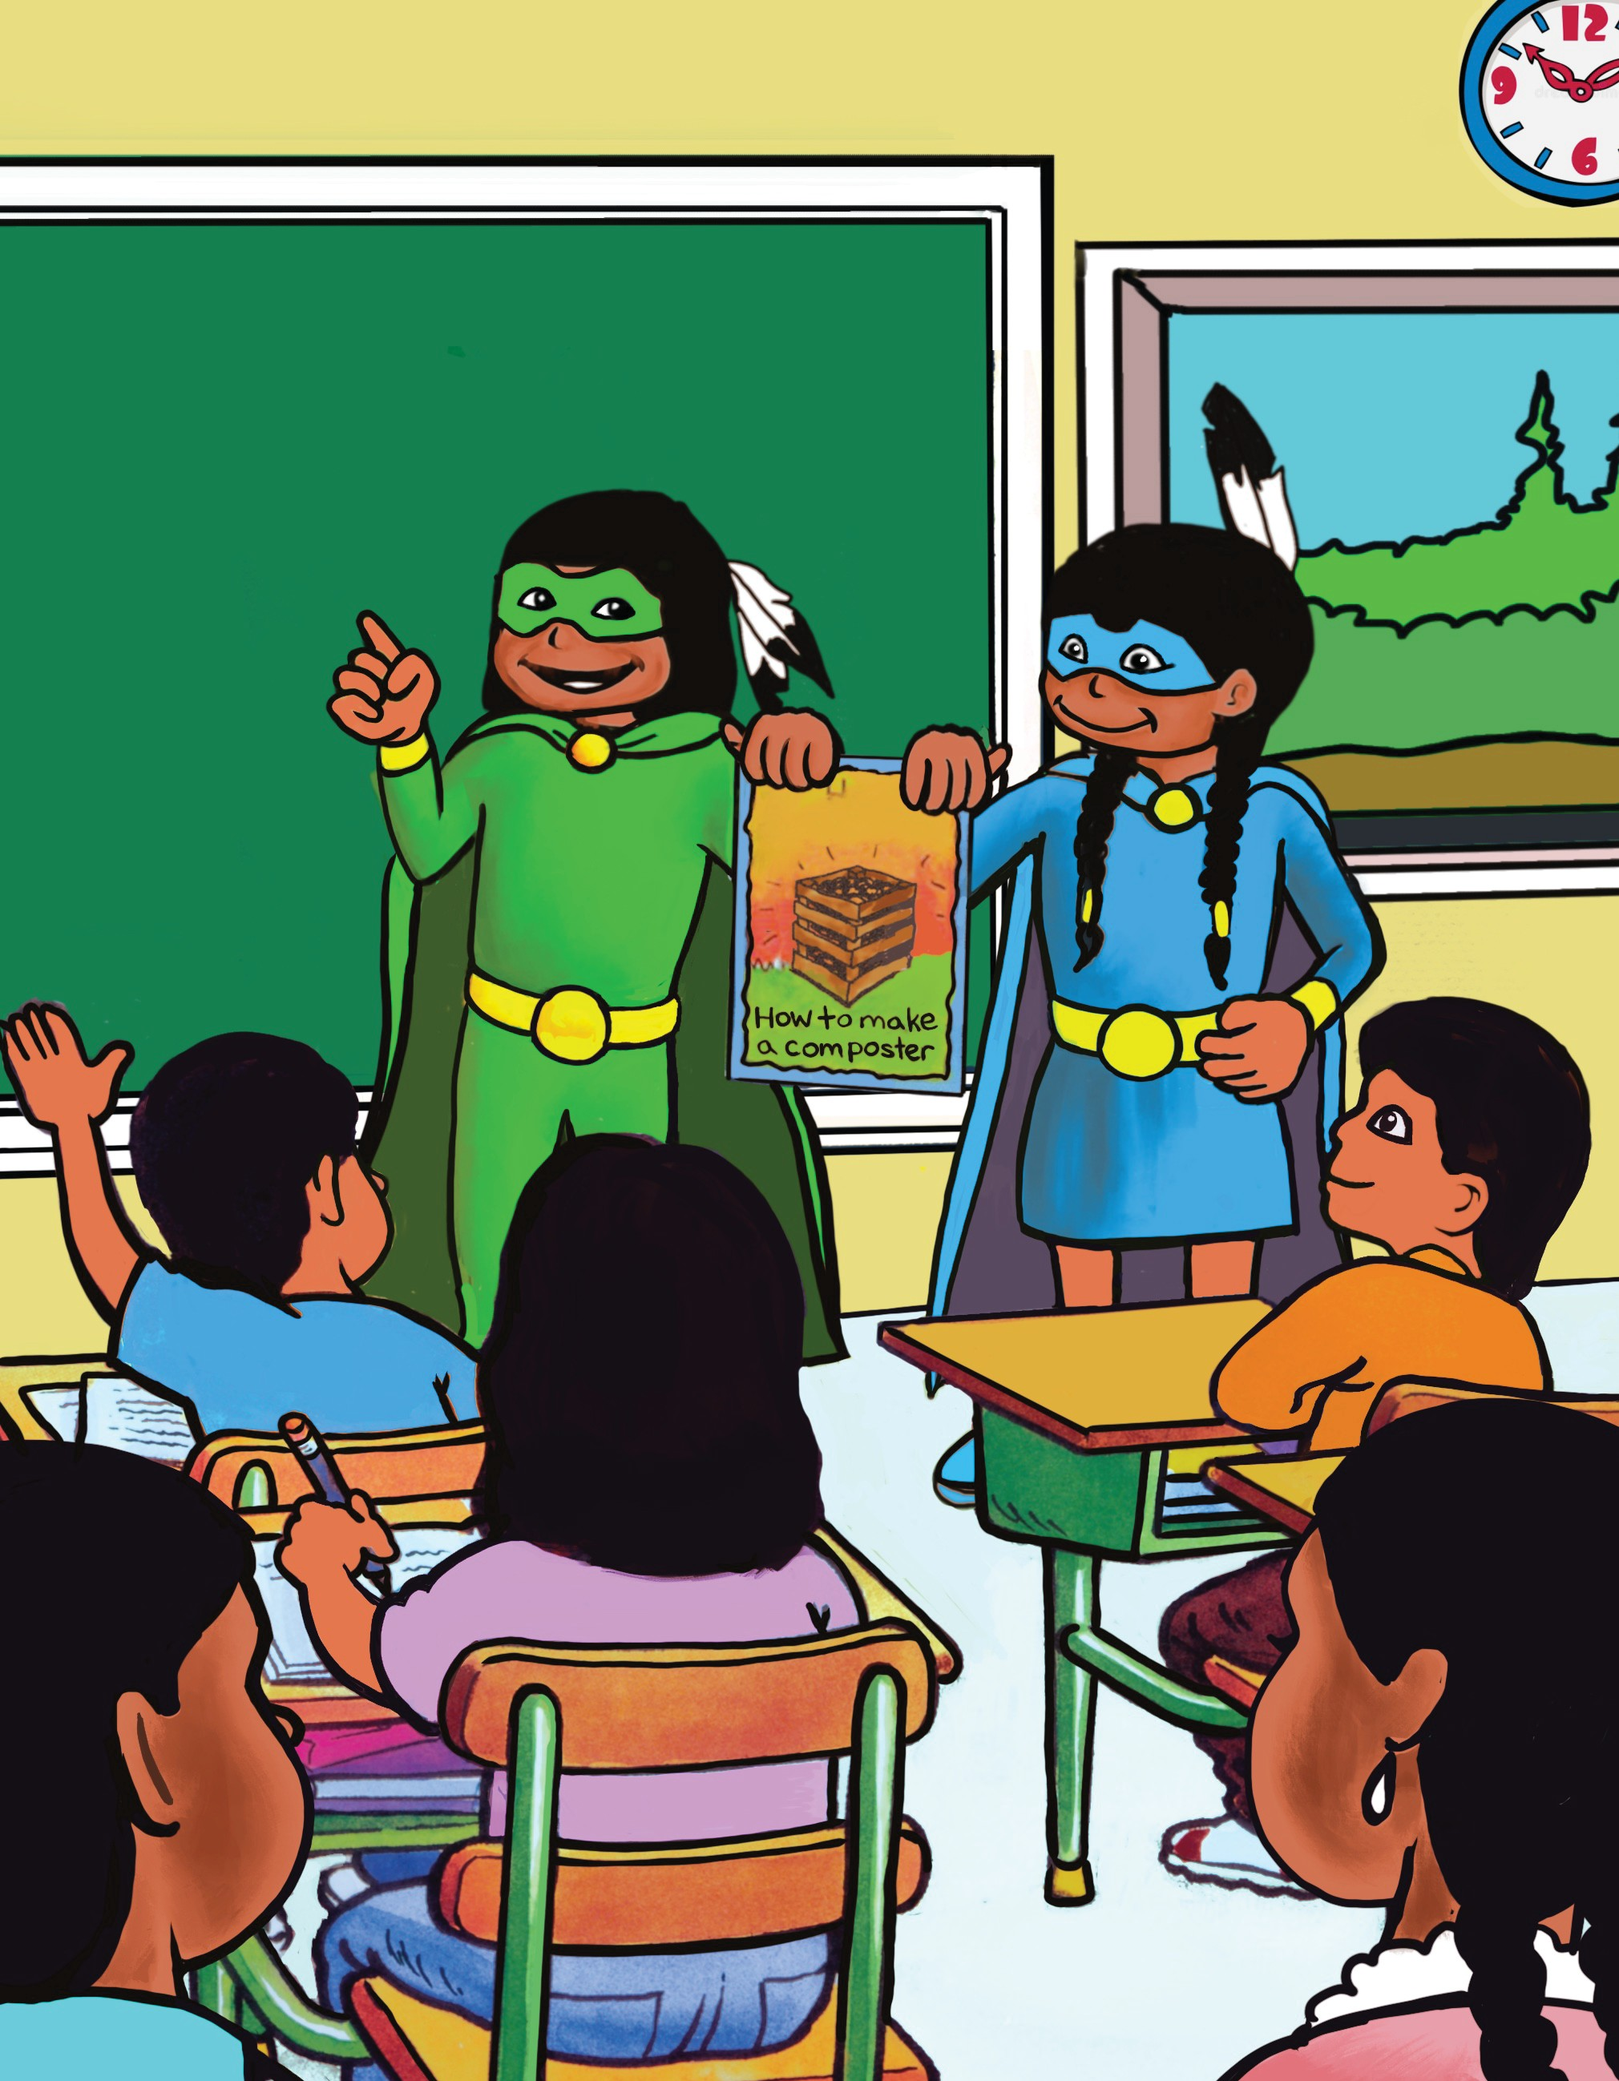

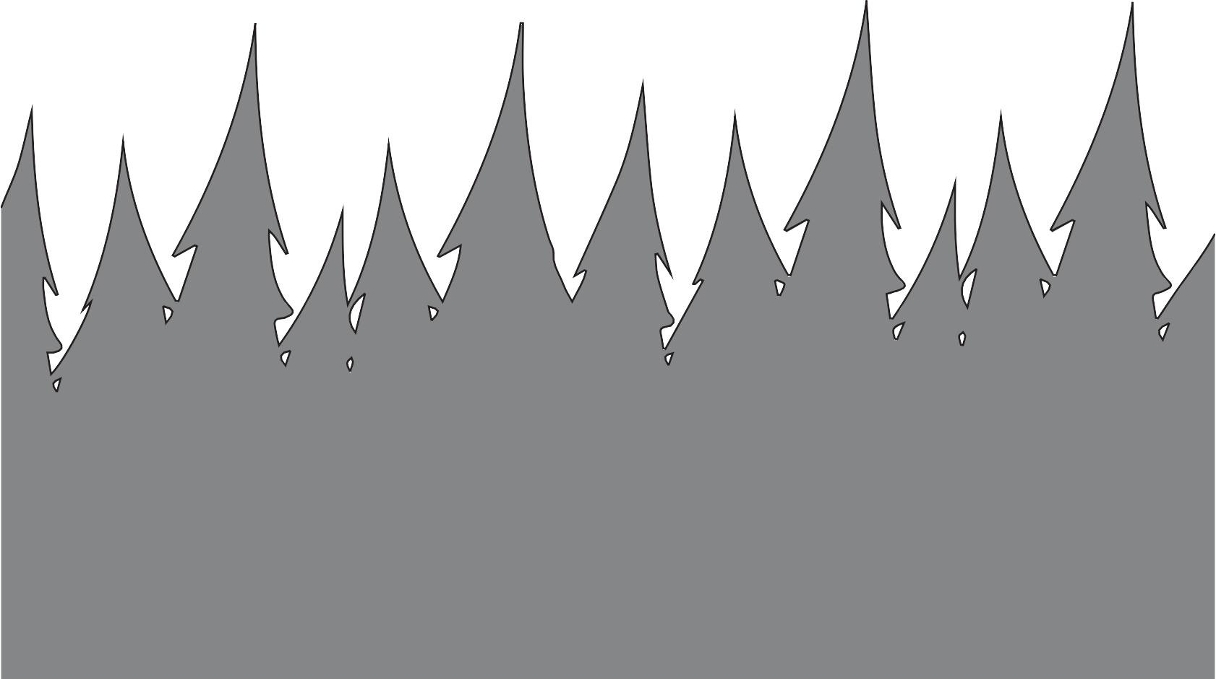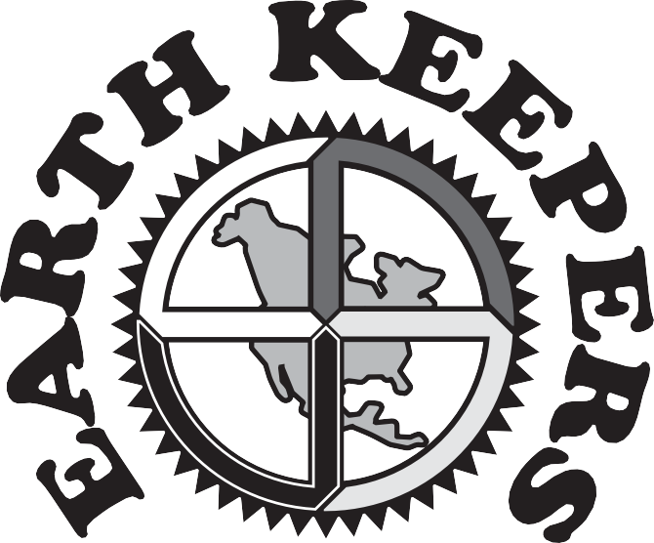

As Earth Keepers we are all responsible for protecting our Mother Earth. First Nations Technical Services Advisory Group (TSAG) created this activity book to introduce students and their parents to the 4 Rs of Reduce, Reuse, Recycle and Recover. Earth Keepers is a FNTSAG program that educates youth about waste diversion, safe management of hazardous waste, the impact of unauthorized dumping on the environment and the dangers of burning waste.

PDF copies of this booklet and other educational materials are available from TSAG
Telephone: 780-483-8601 • Email: environment@tsag.net

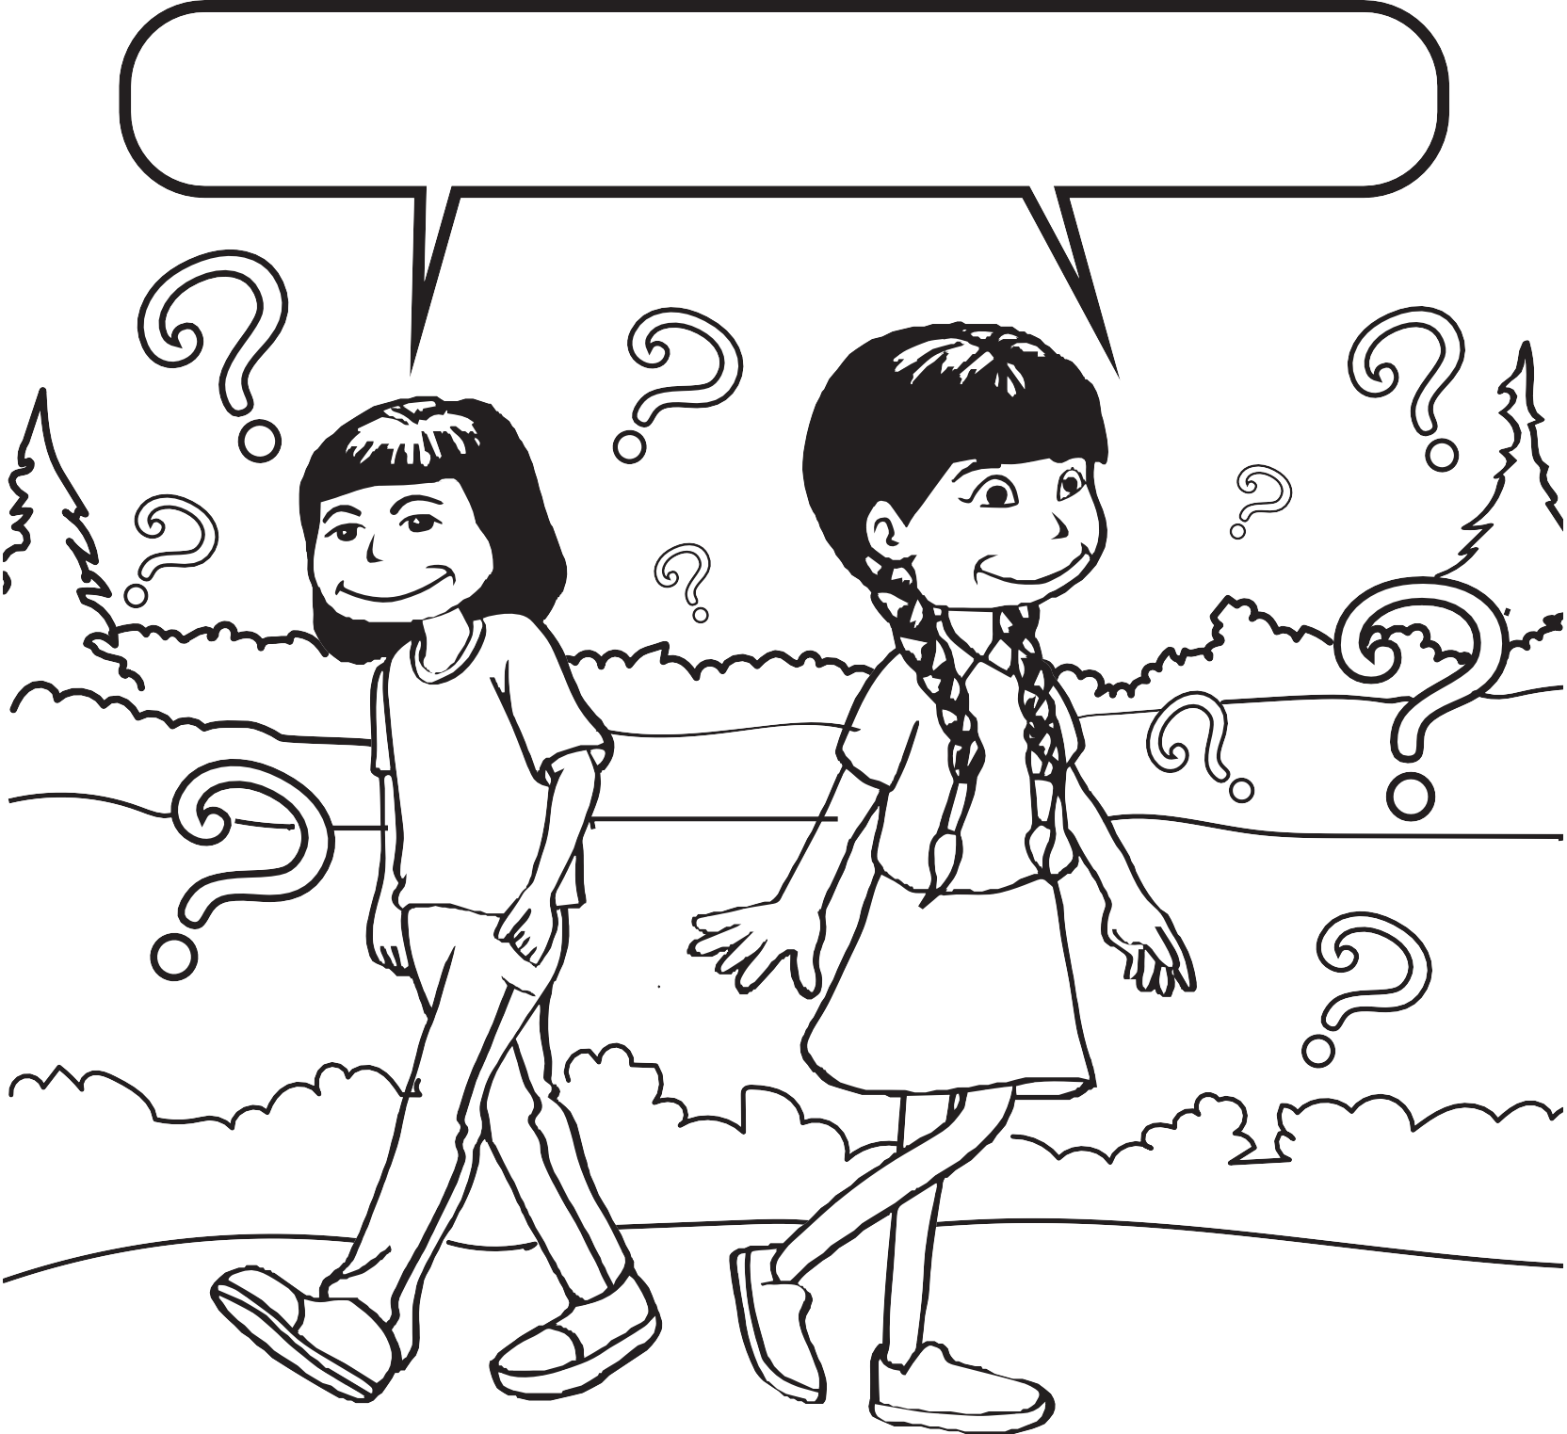

Who is an Earth Keeper?

You can be an Earth Keeper too if you believe in caring for our Mother Earth

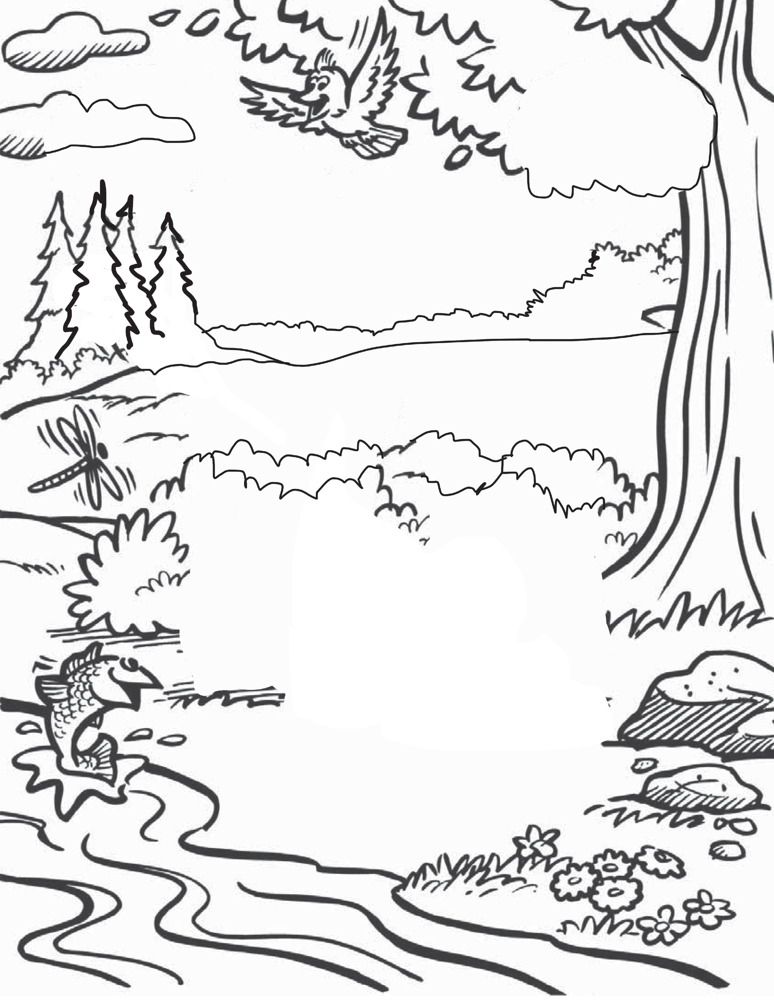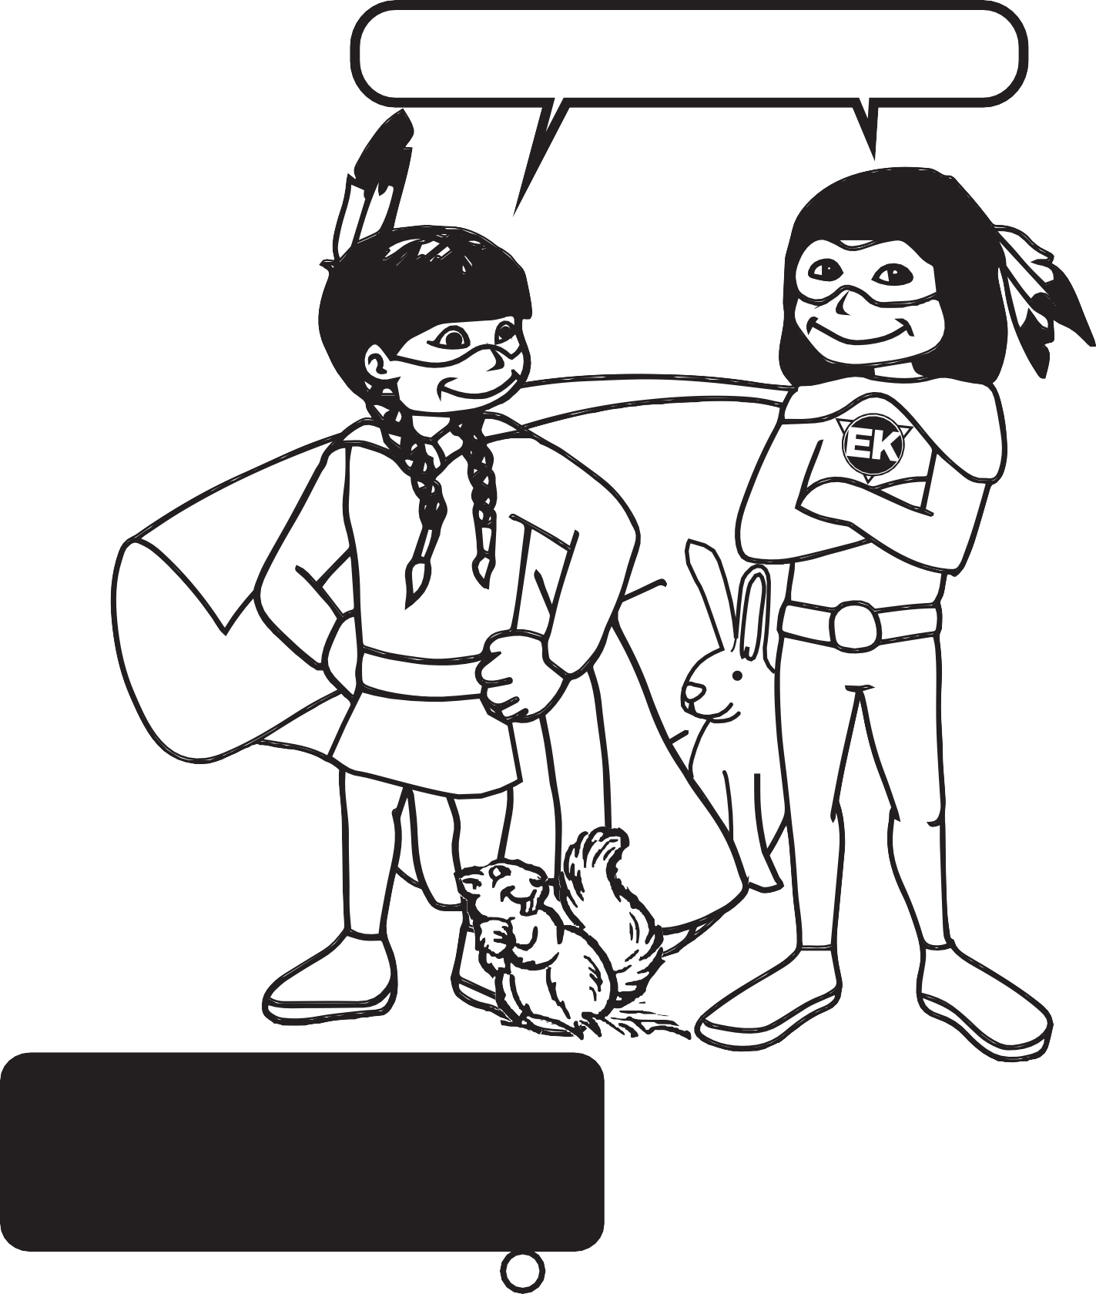

We are Earth Keepers

These Earth Keepers will be your guides.
They will help you to be a Protector of Our Mother Earth

Do you think you could be an EARTH KEEPER?
Try the following quiz and see! Score 2 points for YES and 1 point for NO.
- I care about my environment. 
- I save my juice cans and return them for a refund.
- I put my vegetable and fruit scraps in the compost.
- I write on both sides of my paper before I put it in the recycling box.
- I turn off the tap when I‛m not using the water.
- I only take what I will eat during meal times.
- I put litter in the garbage can.
- We recycle at home and school.
Check Your Score!
6–8 points 9–10 points 11–12 points

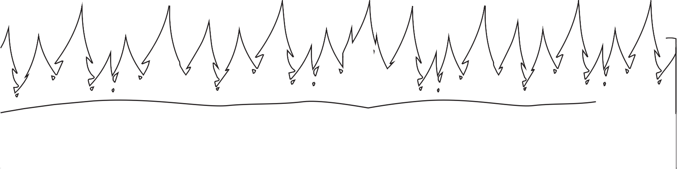Let‛s get you started!
You are on your way!
You are an Earth Keeper!

Ask your Mom or Dad to help you look in one bag of garbage at your house. See if there is anything that need not have been thrown away.
Maybe it could have been used differently.

Join the dots to find the answer to
the secret message A
below.
H I
F J
B G K
E

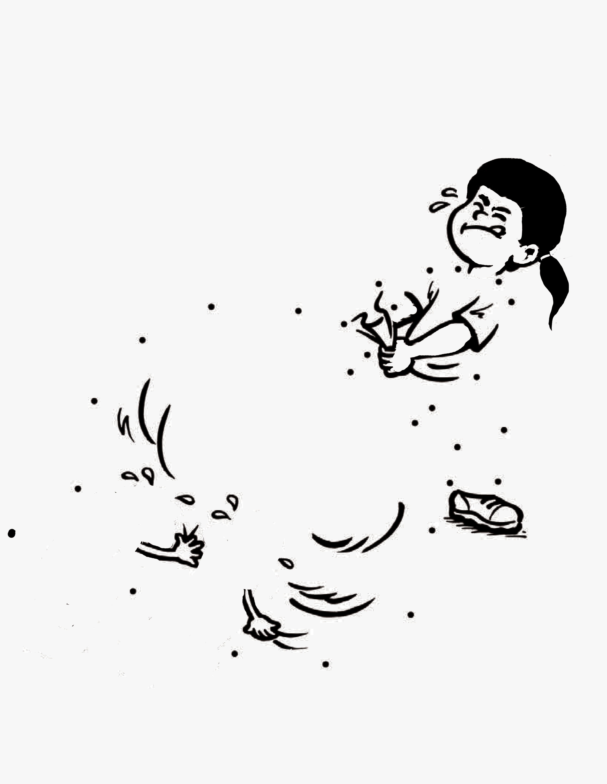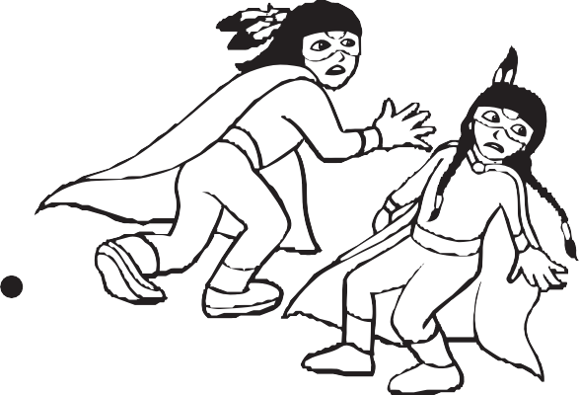Z
C D L
Y Q
R M
P
O
X N

S

W T

V U
Too much !

4

What is Waste?
Waste is anything you throw away when you are finished with it.

Used toys and clothes

Packaging

Kitchen and yard waste
Reuse things many times before throwing them away

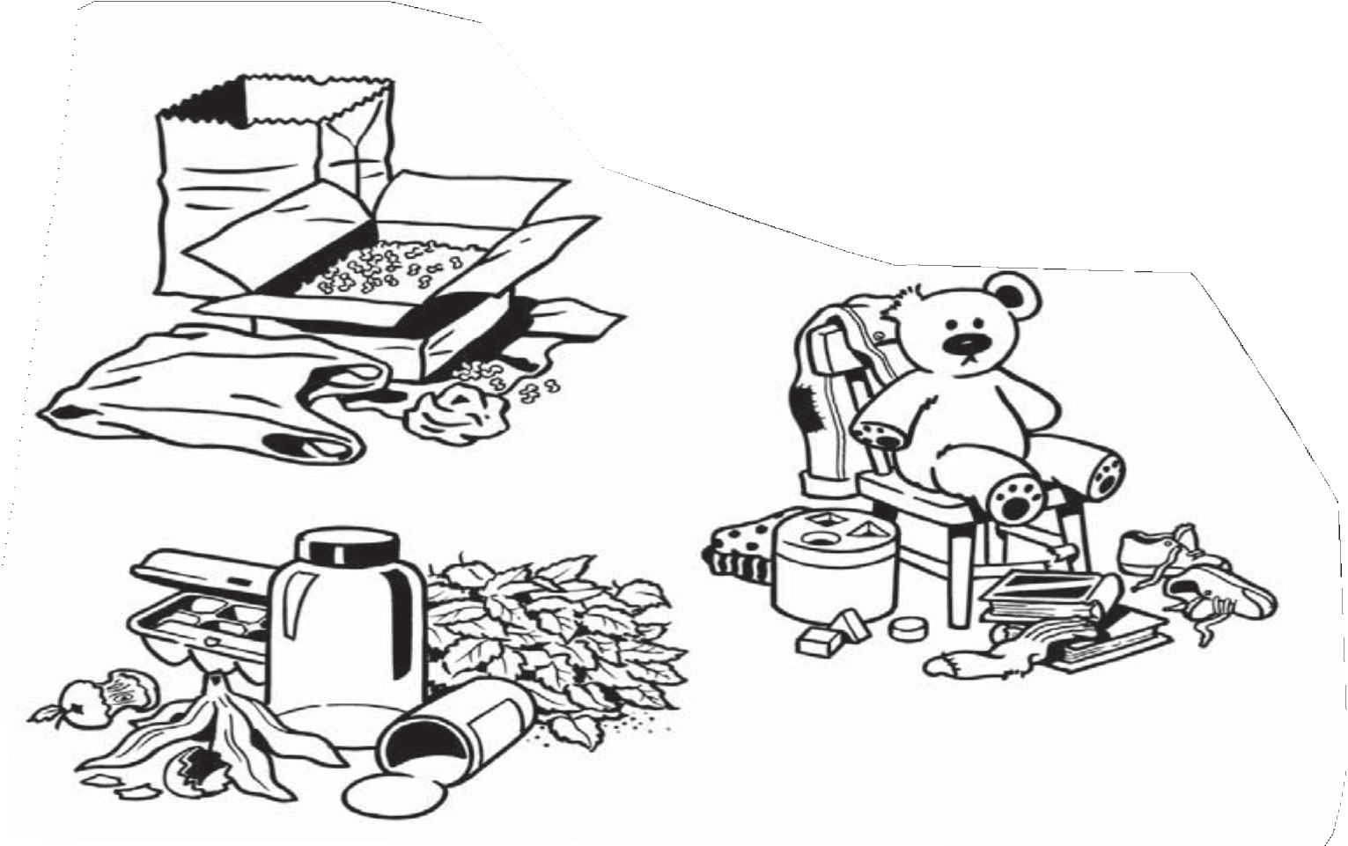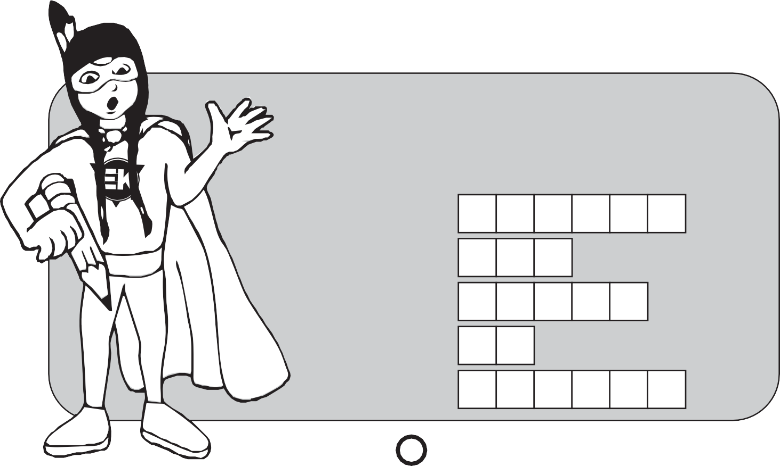
Secret Message
Unscramble the letters in each word below to find out what Winnie‛s message is.
P P E O L E P P
N A C A
E A R N L L N

O T
R E U C E D D E

5

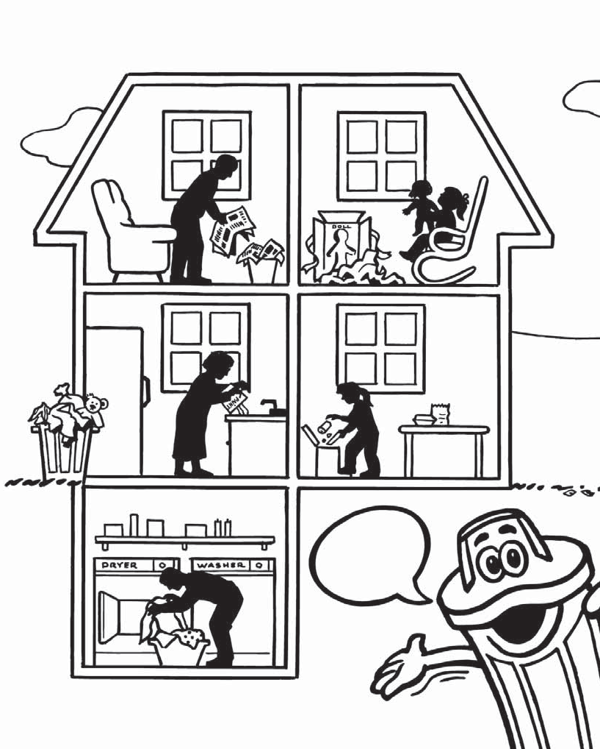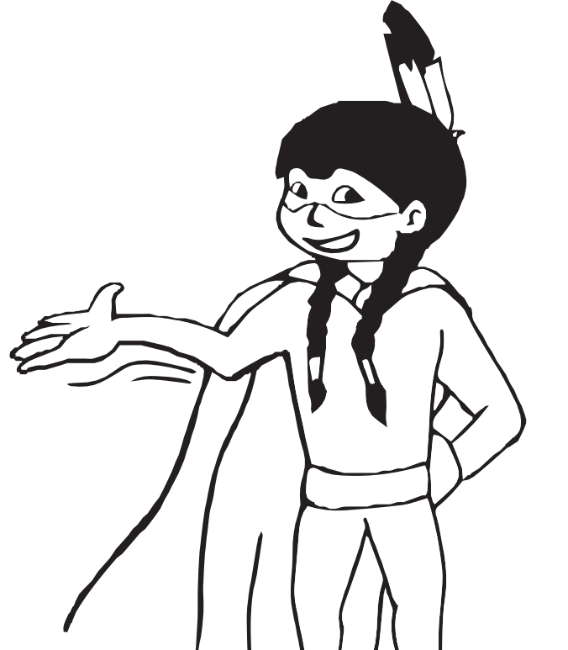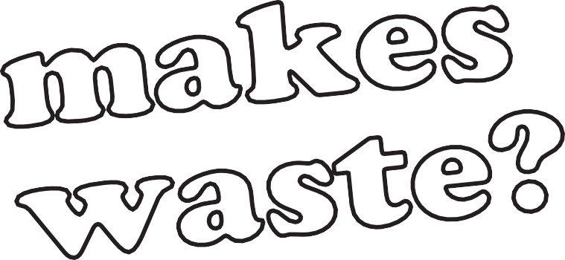

We ALL
do!

6

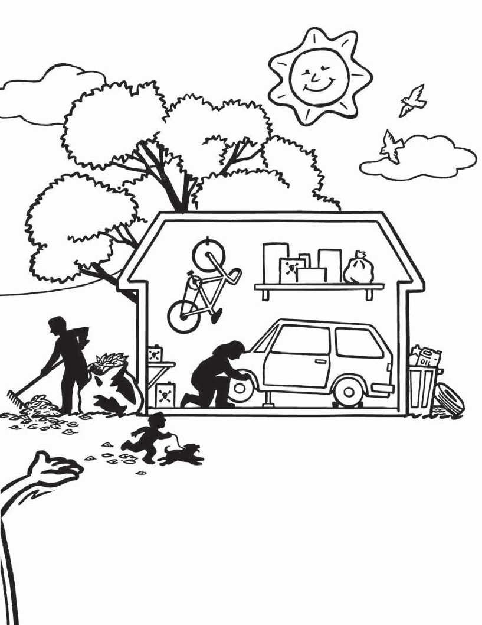

Earth Keepers see 6 things in this scene which are wasteful, dangerous or harmful to the environment.
Circle the ones you can find.

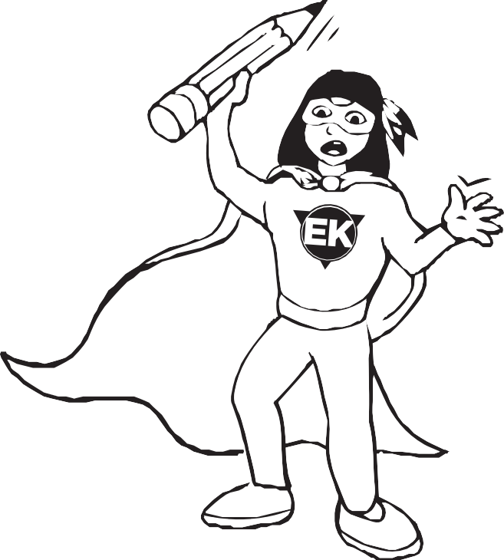
Secret Message
Unscramble the letters in each word below to find out what the Earth Keeper‛s secret message is.
P P E O L E N A C
E A R N L O T
U S E R E
N
E
E
Make less household waste
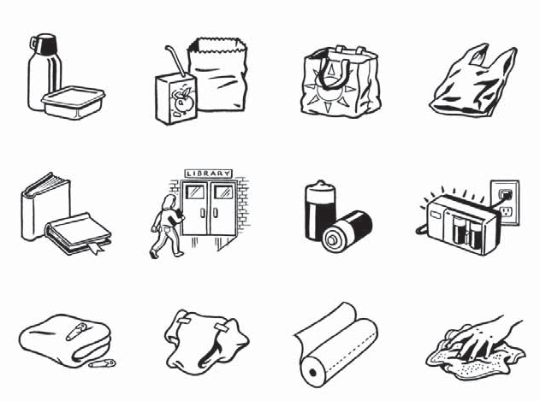by using things that are reusable.
Circle the reusable item in the item pairs below.

Thermos and snack pack | OR | Juice box and paper lunch bag | Cloth bag | OR | Plastic bag
New books | OR | Library books | Throw away batteries | OR | Rechargeable batteries
Cloth diaper | OR | Disposable diaper | Paper towel | OR | Cloth rag

 | E |  | R

R |  | U

Recycling
means to collect things so that
they can be made into new things.

Sort the things below by putting them in the correct recycling bin.
Draw a line to the proper bin.

Roof Shingles
Reinforcing Bar (used in construction)
Glass bottles
Newspaper
Plastic flower pots and plastic wood

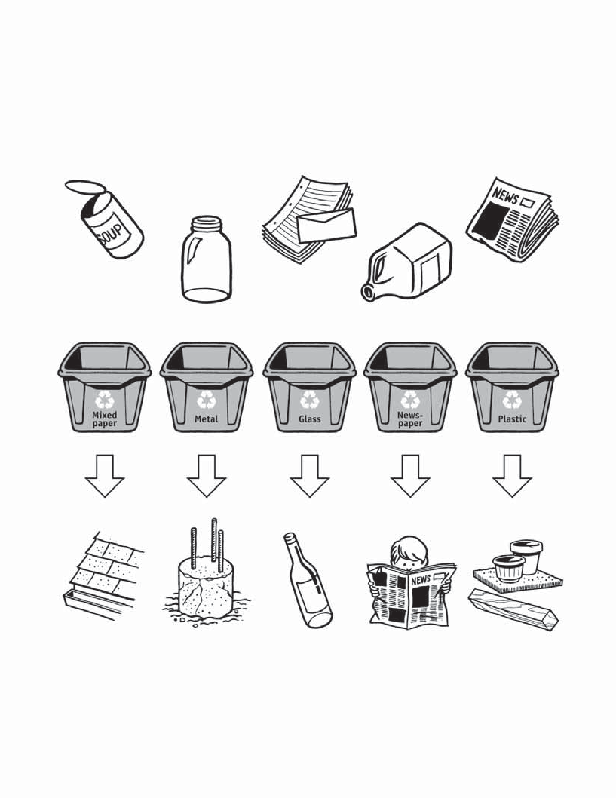

Here are some of the new things made from the old things.

9

Start

Glass
makes glass beads for road paint

Paper makes new
envelopes

Plastics make new school binders

Paper makes
roofing shingles
Glass makes new glass jars and bottles

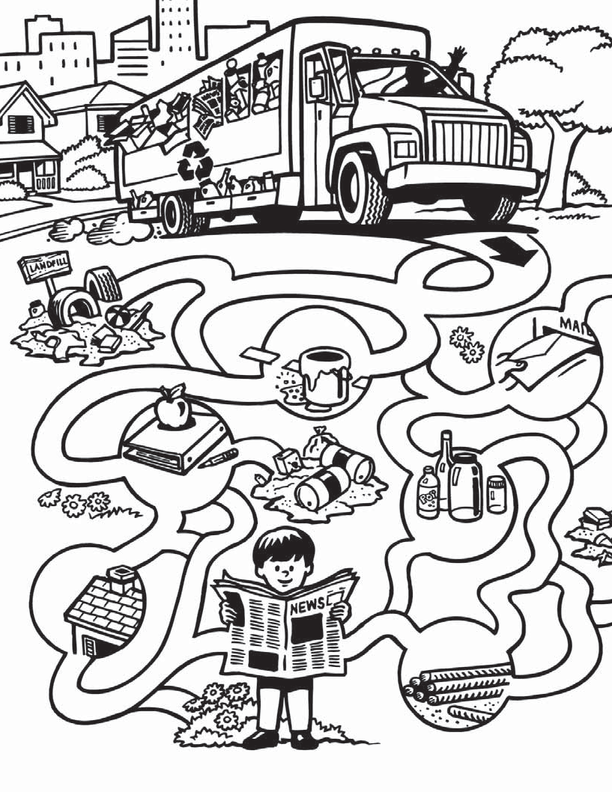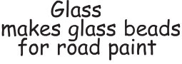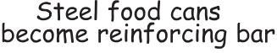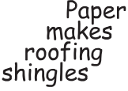

Steel food cans become reinforcing bar

Old newspaper makes new newspaper

10

Show the collection truck how to reduce its load

by recycling materials instead of sending them

to the landfill.
Plastic makes new shampoo bottles

Old paper makes
new paper products

Plastics become new carpet

Aluminum pop cans
become new pop cans

Plastic makes
plastic wood
Old tires become rubber playground mats

Great Job!

Tires make rubber door
mats

Finish

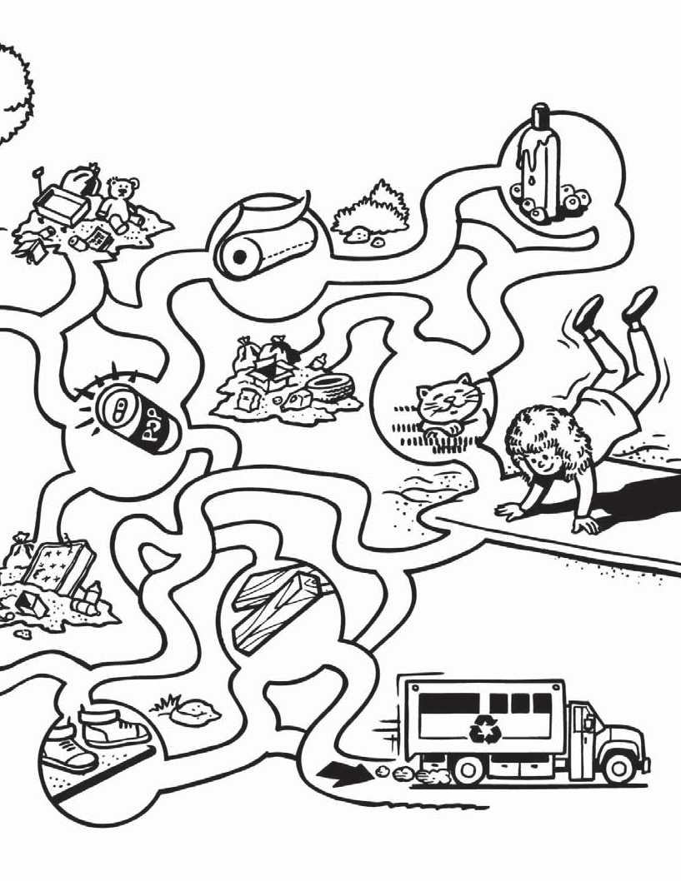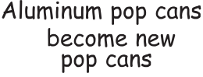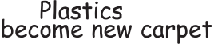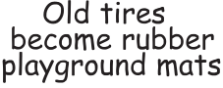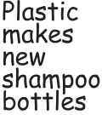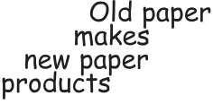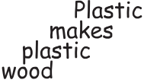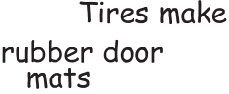11

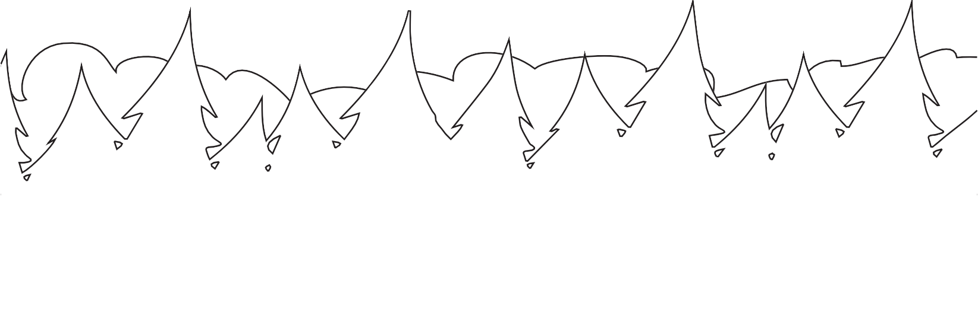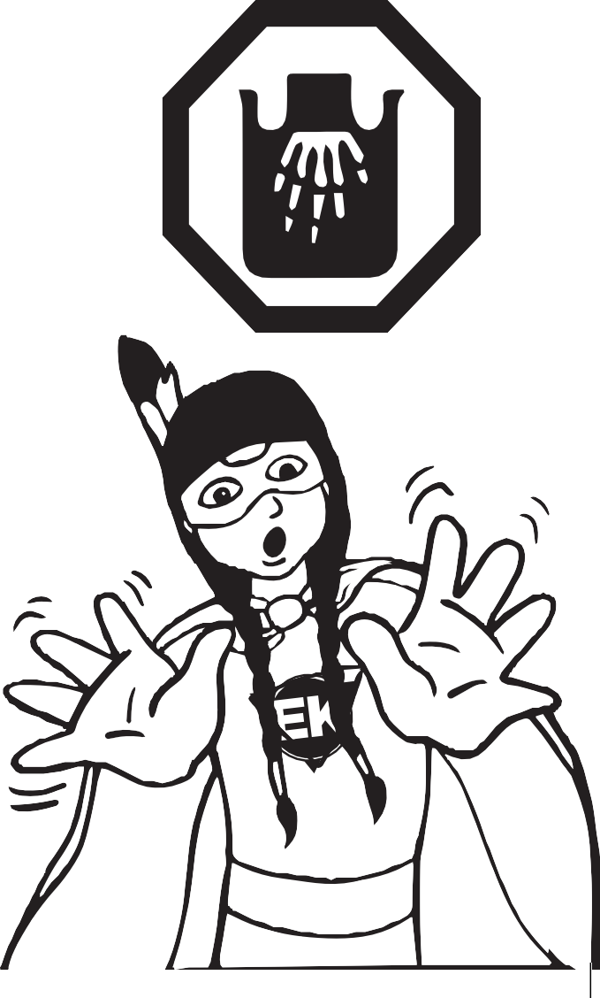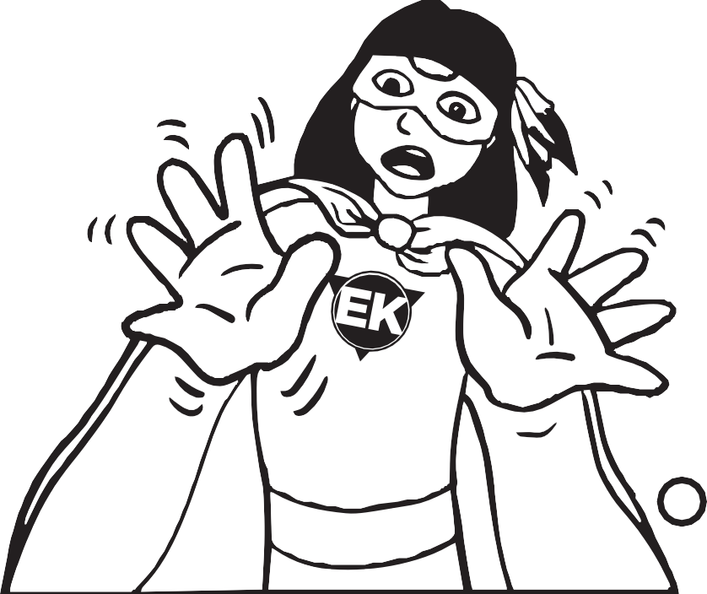

Earth Keeper
Watch out for
these danger signs!
What do you see?
I see a POISON sign Looking at me!

Earth Keeper
What do you see?
I see a FLAMMABLE sign
Looking at me!

What do you see?
I see an EXPLOSIVE sign Looking at me!

Earth Keeper
What do you see?
I see a CORROSIVE sign
Looking at me!
Earth Keeper What do you say? “HANDS OFF!”

12

Household Hazardous Waste Round-Ups

Wastes with these symbols and others are hazardous. These wastes are collected at Household Hazardous Waste Round-Ups. Then they are sent to a waste treatment plant instead of having them end up in a landfill.
Send the hazardous wastes shown below to the Swan Hills Treatment Centre by drawing connecting lines.

Swan Hills Treatment Centre
Pesticides

Poisons

Cleaners

Edmonton
Red Deer Calgary
Medicine
Hat
Lethbridge
Oven cleaners

Paint

Herbicides

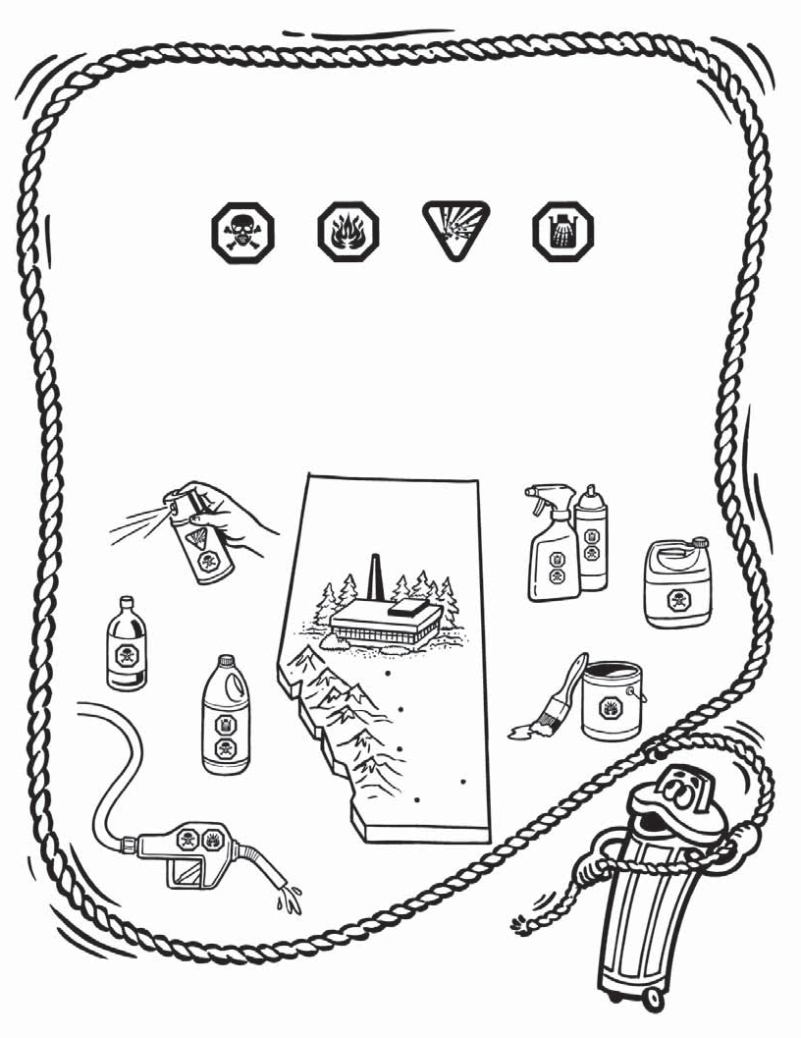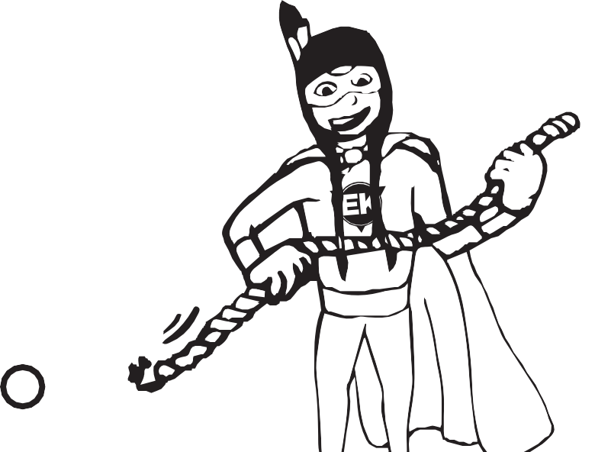

Gasoline

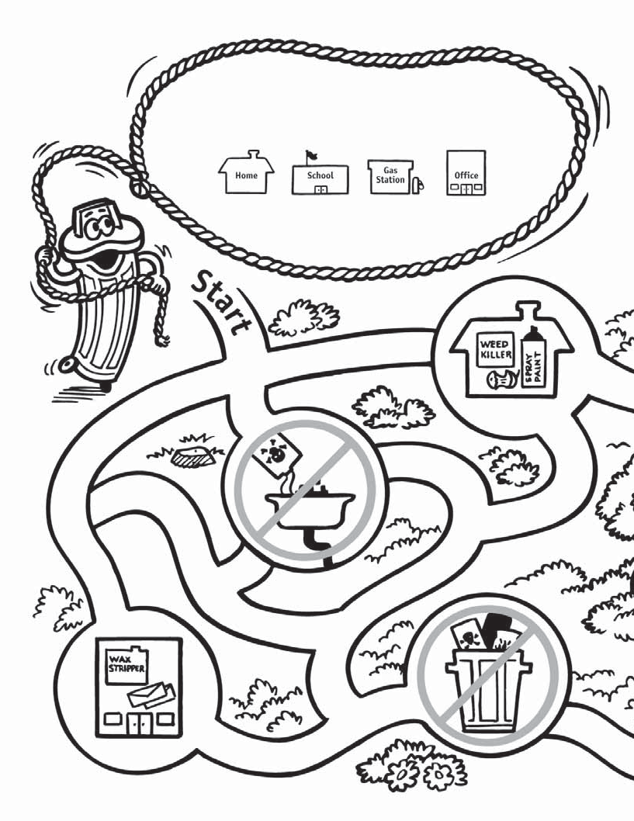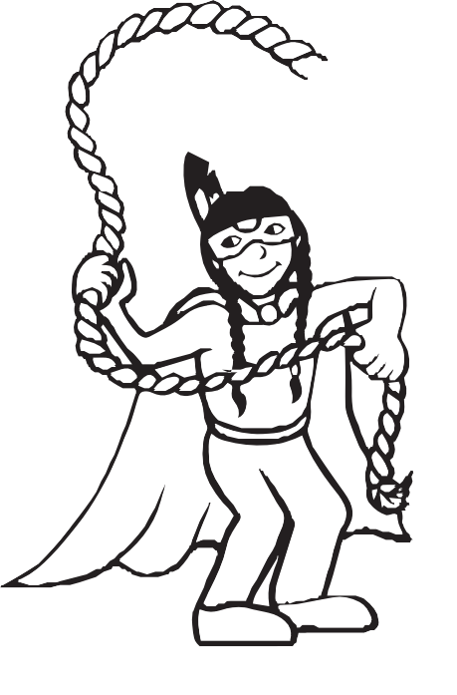

Follow the path
to the waste treatment plant. At each stop,

circle the waste item which should be sent to the plant.

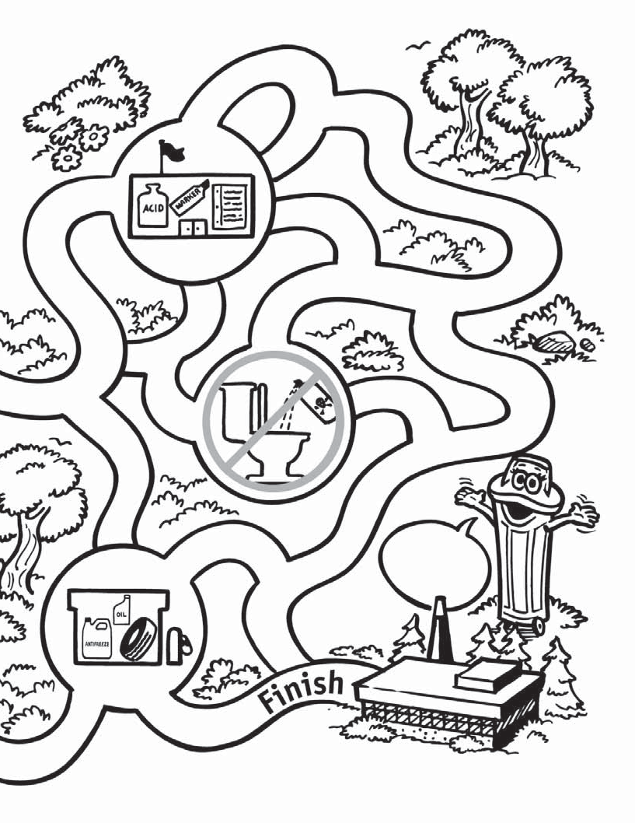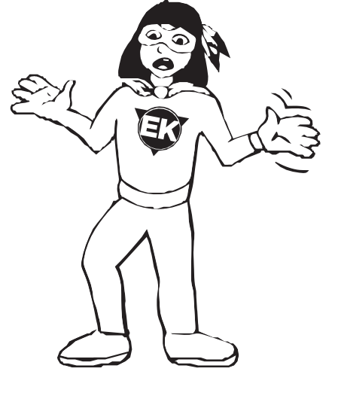

Way to go!

15 5
151
Waste Treatment Plant

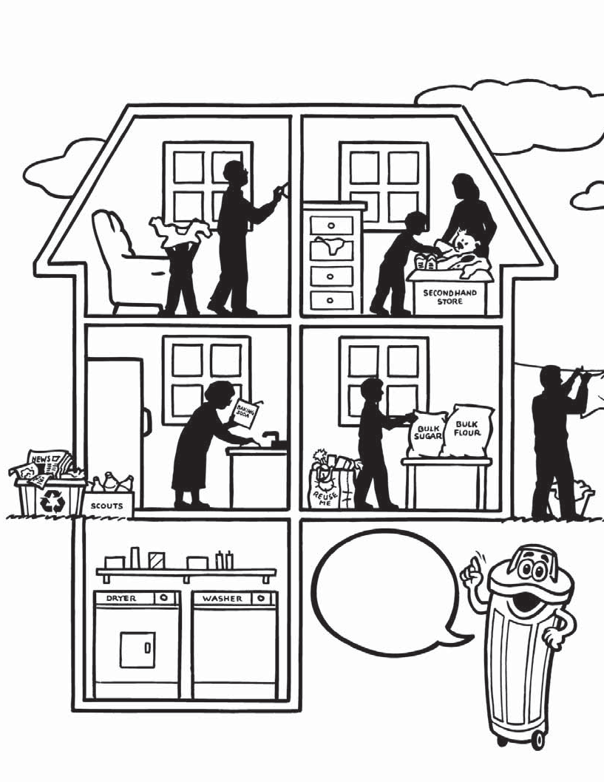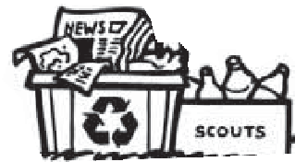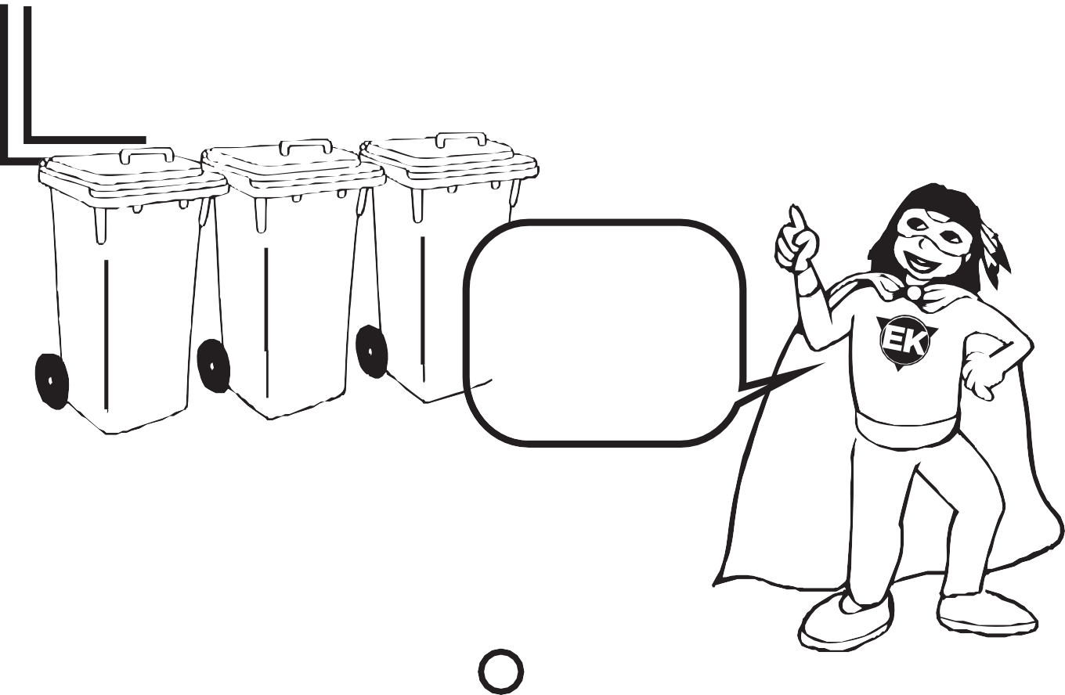

We can all be kind to our

Circle all the things that are good for the environment in this picture.

16

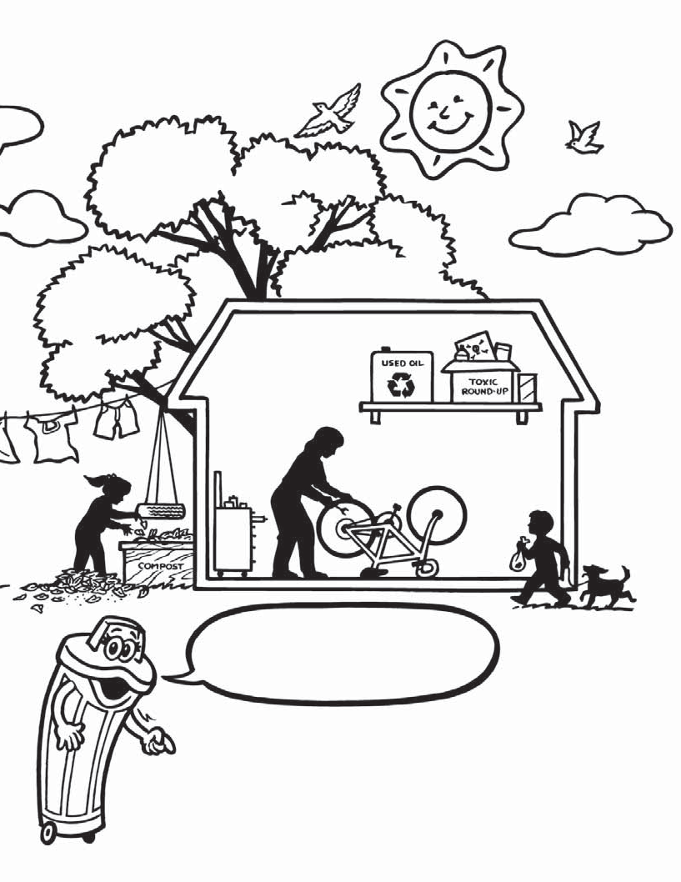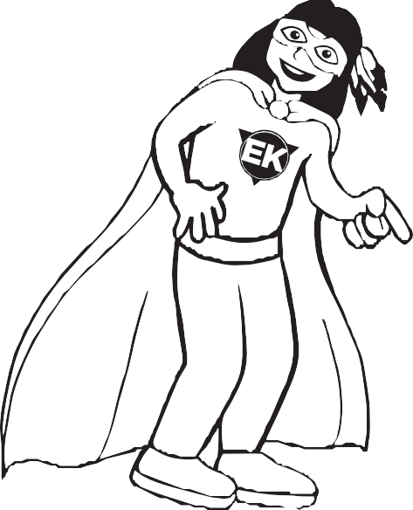

environment!

Write a sentence about one of the things you do that is good for the environment.

17

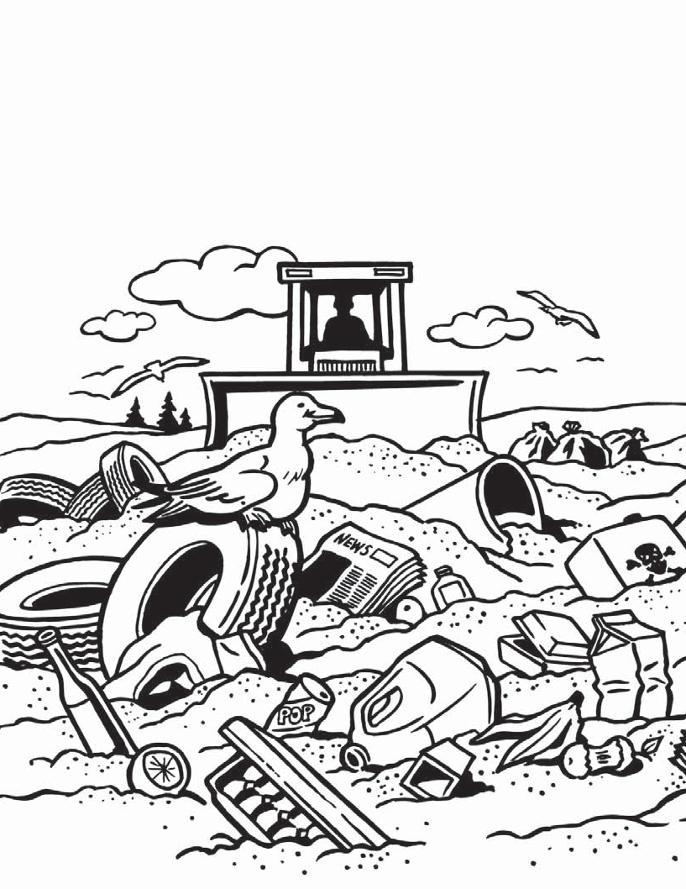Where does waste go?
Most of our waste gets buried in the ground in what is called a landfill.
All of the things at the top of the next page should not be in the landfill.
Find them in the landfill below and colour them.

18

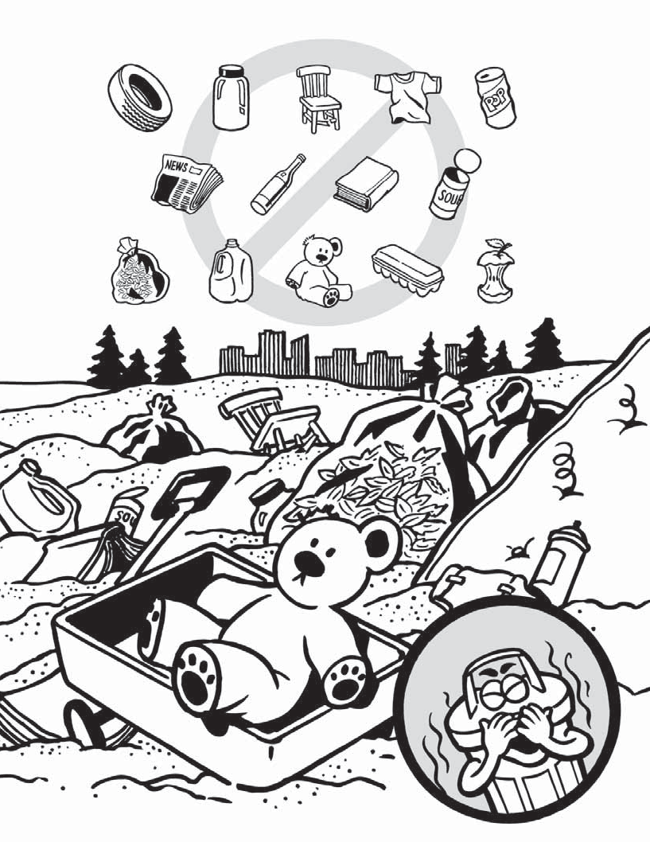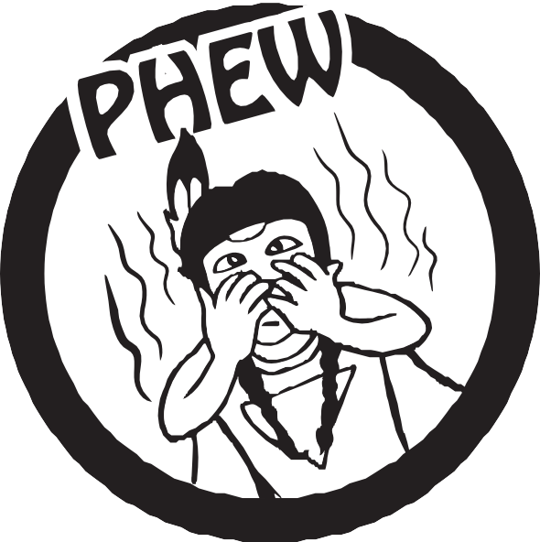

for parents and teachers
Suggestions

- Take your child or class to the nearest landfill site for a visit and discuss ideas of waste.
- Discuss ways to eliminate some of the waste by reducing, reusing or recycling.
- Demonstrate how packaging can be reduced by buying in bulk, bringing your own bags, or refusing bags for small items.
- Find a community secondhand store to send clothes and toys to, or even better, trade with family and friends.
- Keep scrap paper available and use flyers for children‛s cutting projects.
- Start a paper recycling program in your school or place of work.
Did you know?
A fast food company with restaurants all over North America uses enough burger boxes in one year to fill Toronto‛s Sky Dome 20 times.
A cat eats a can of food a day. Each can weighs 40 grams. If the cat lives 15 years, we throw out 5,475 cans or 219 kilograms of steel.
More than 40,000 trees are cut down each day to make news- papers for Canadians to read.
Canadians throw away about seven million batteries
each year.

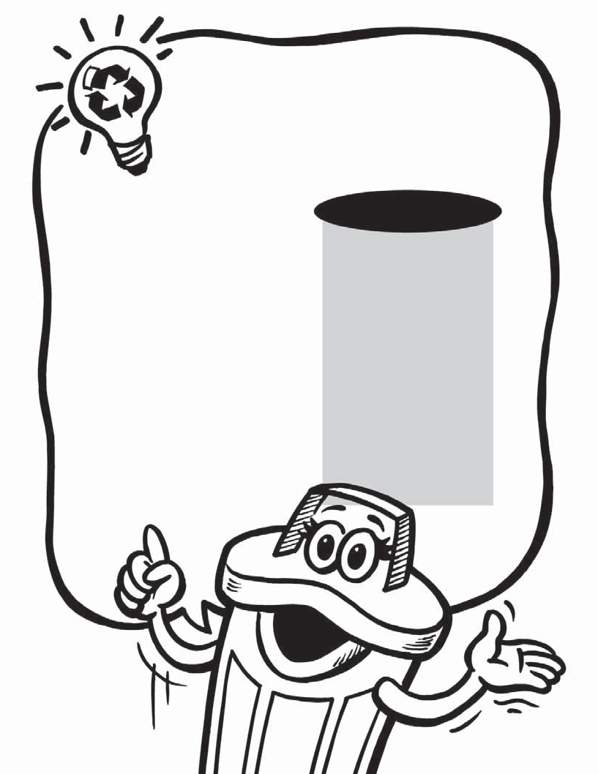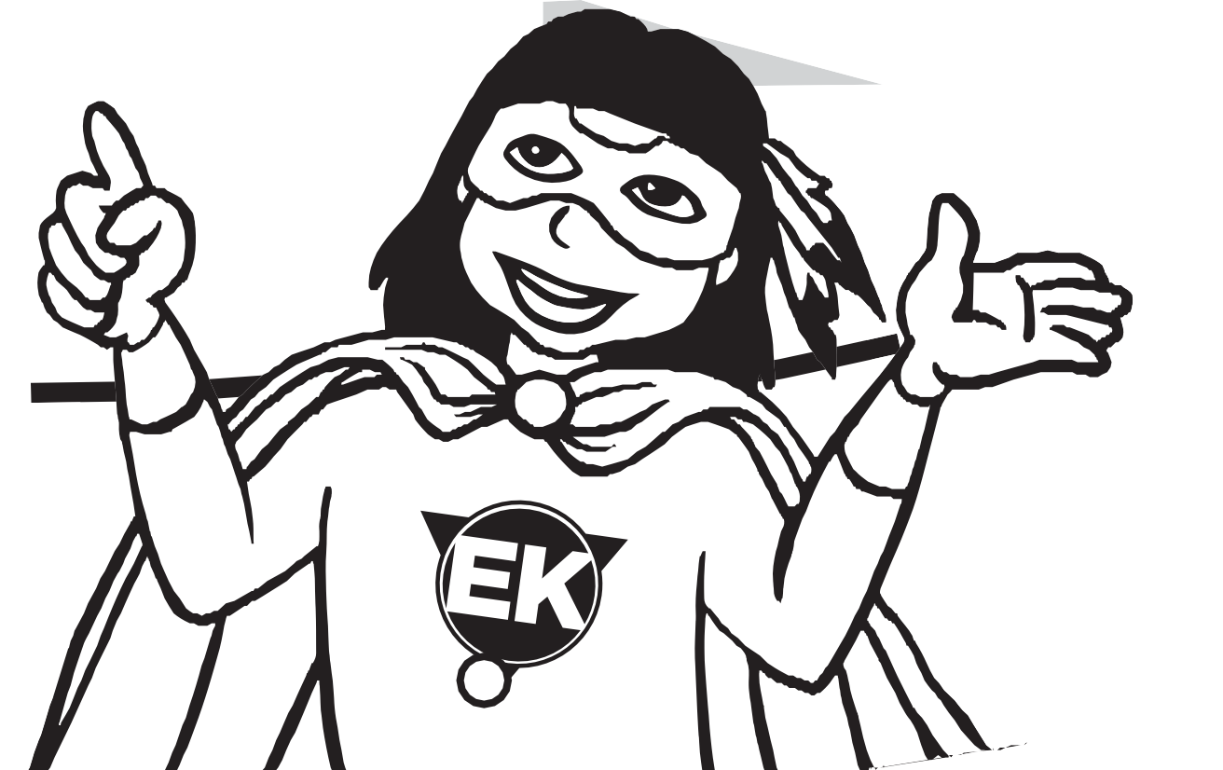

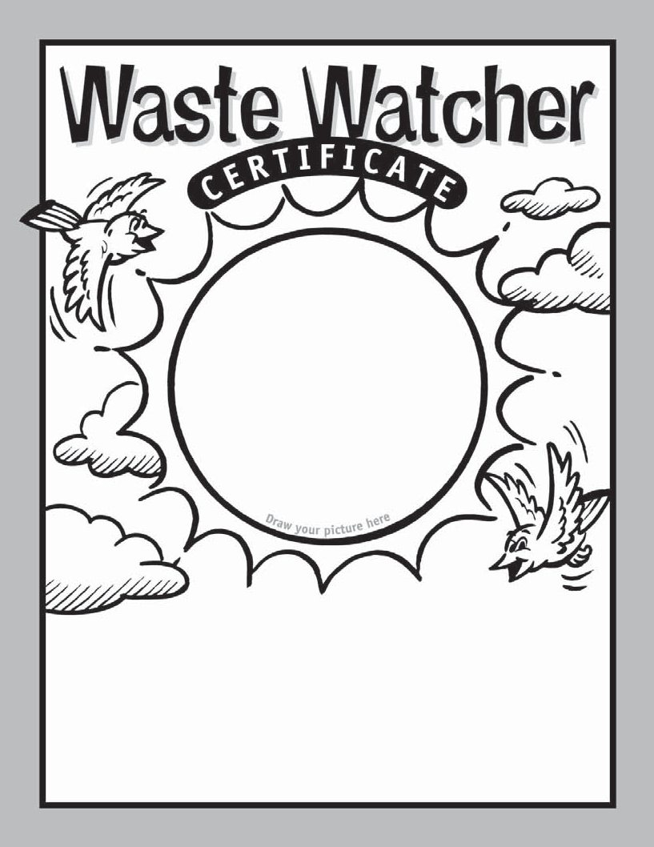Earth Keeper

This is to certify that

is in training to be an Earth Keeper in caring for the environment

Date Parent/Teacher






