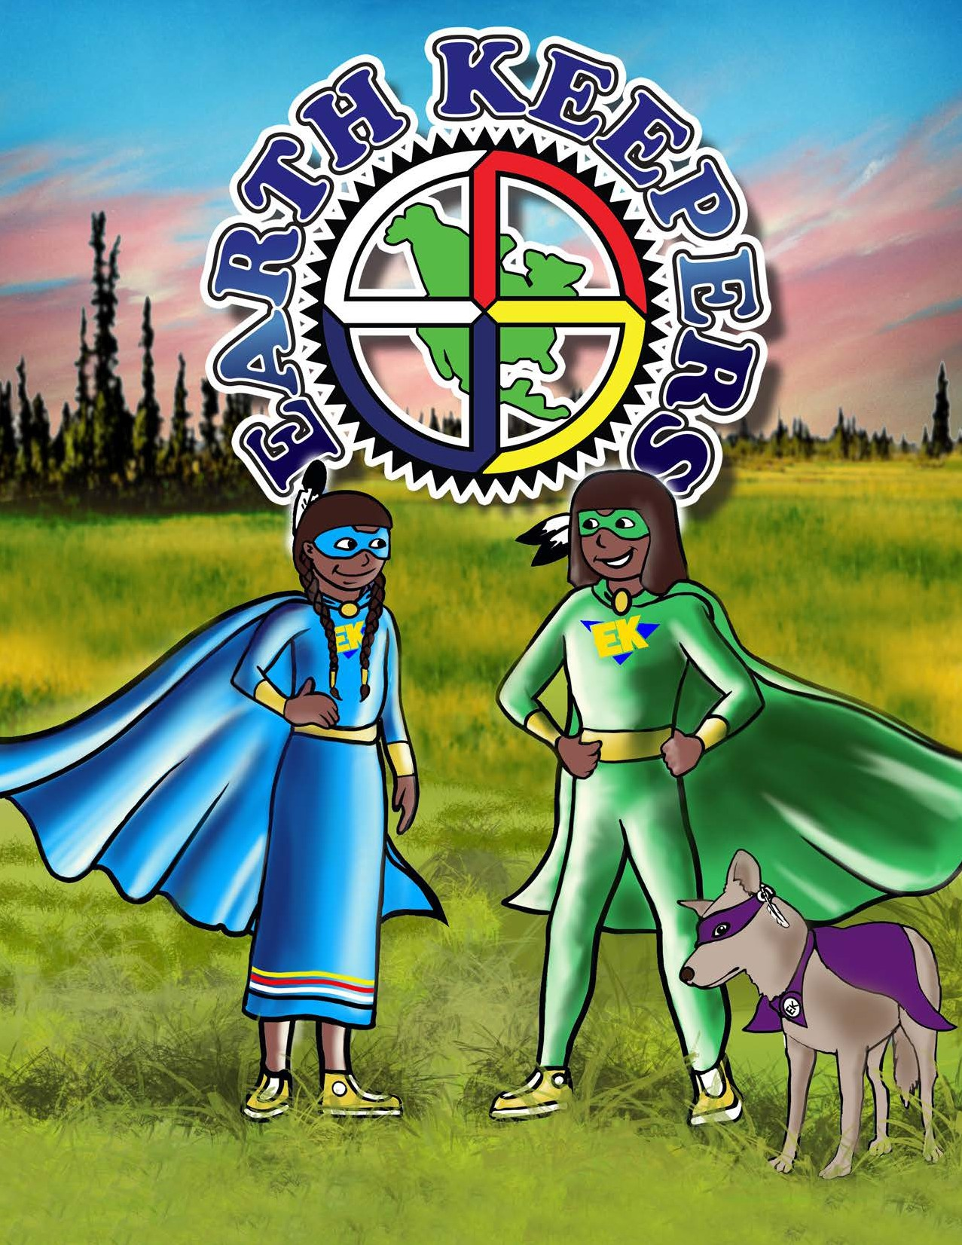Loud

ACTIVITY & Colouring BOOK
VOLUME 2

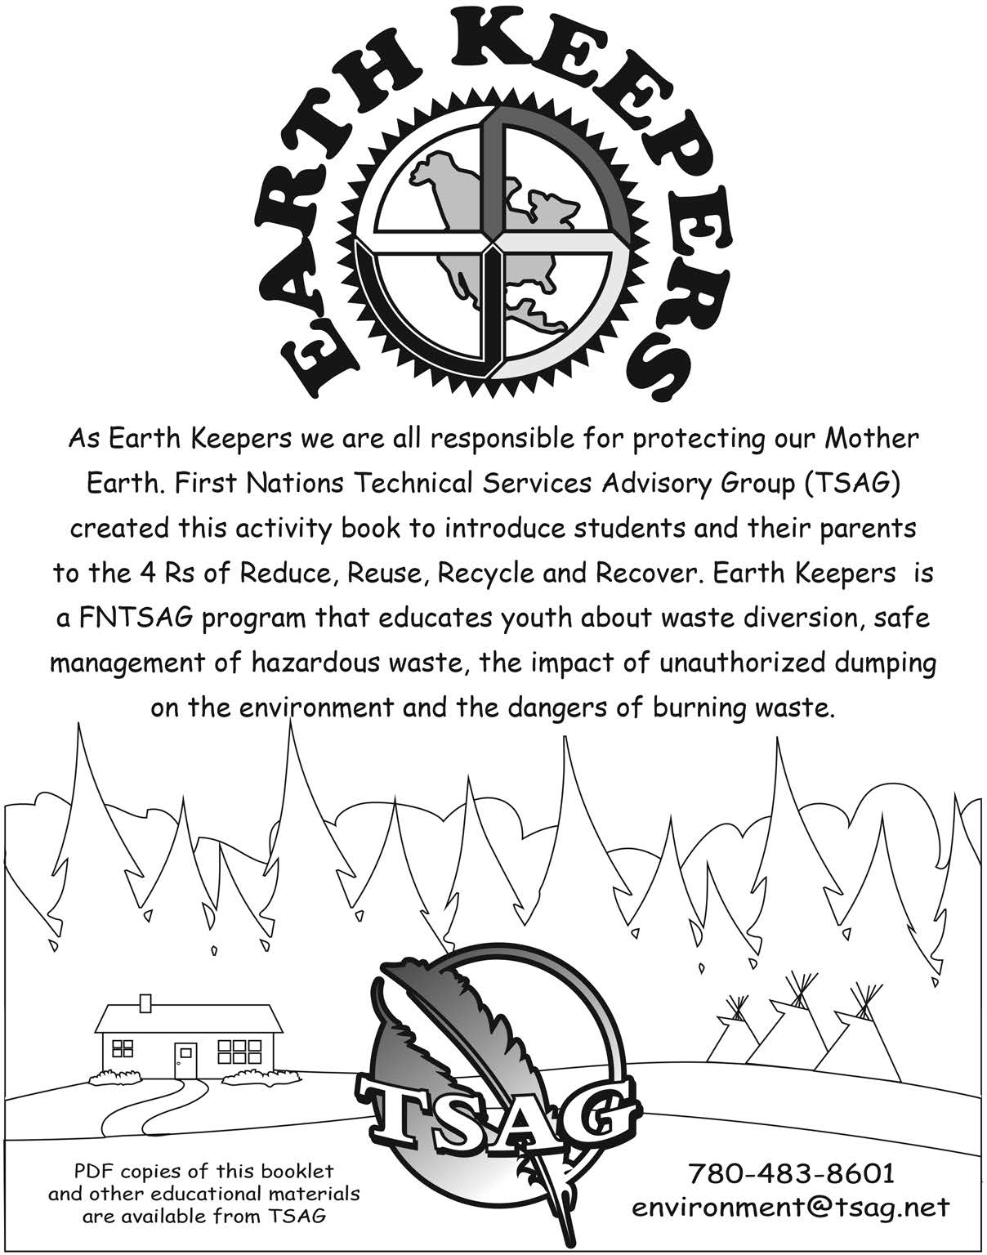

As Earth Keepers we are all responsible for protecting our Mother Earth.
The First Nations Technical Services Advisory Group (TSAG) created this activity book to teach students and their parents the 6 R’s of Rethink, Refuse,
Reduce, Reuse, Recycle, and Recover. Earth Keepers is a FNTSAG program that educates youth about waste diversion, safe management of hazardous waste, the impact of unauthorized dumping on the environment and the dangers of
burning waste, as well as animal safety around waste management.

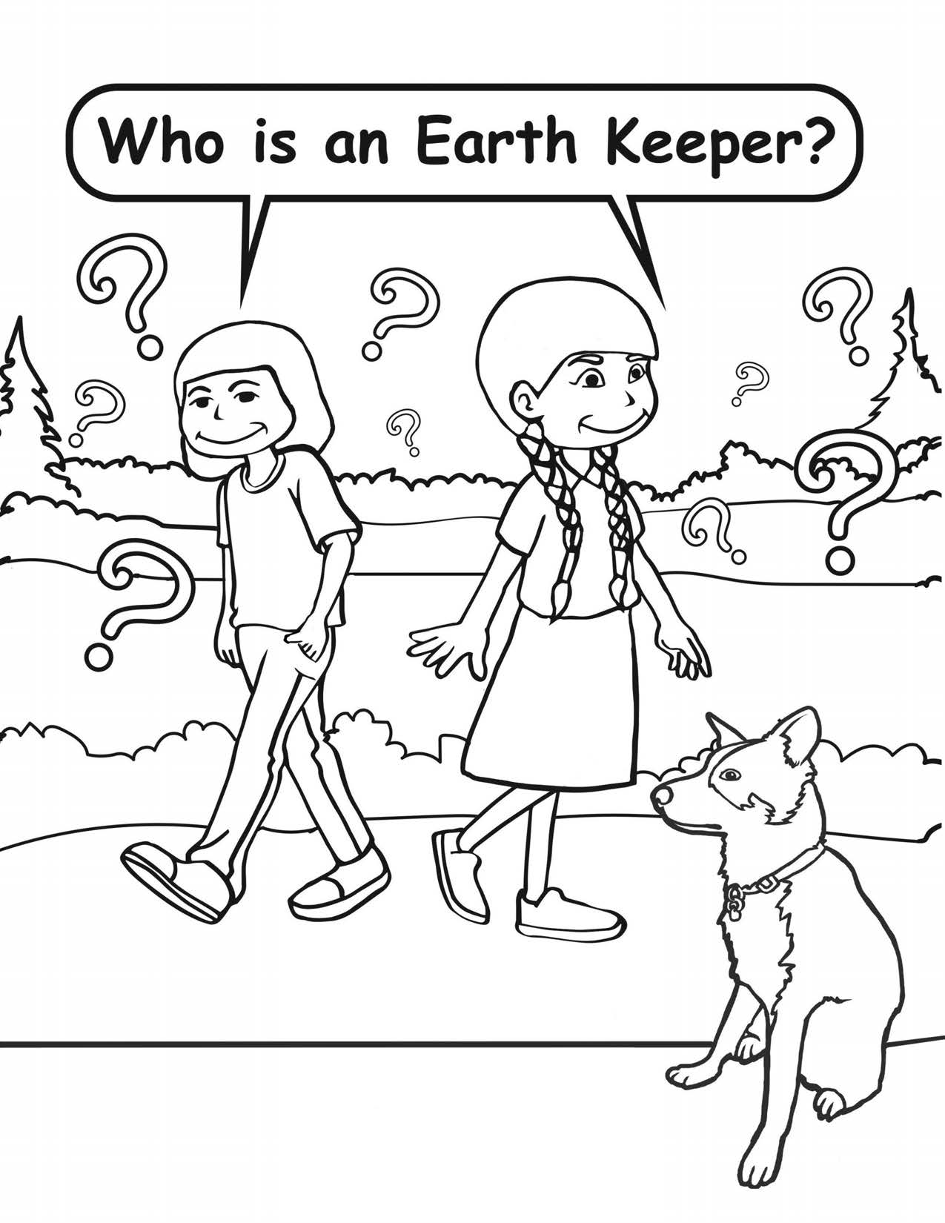

You can be an Earth Keeper too if you believe in caring for our Mother Earth!

1

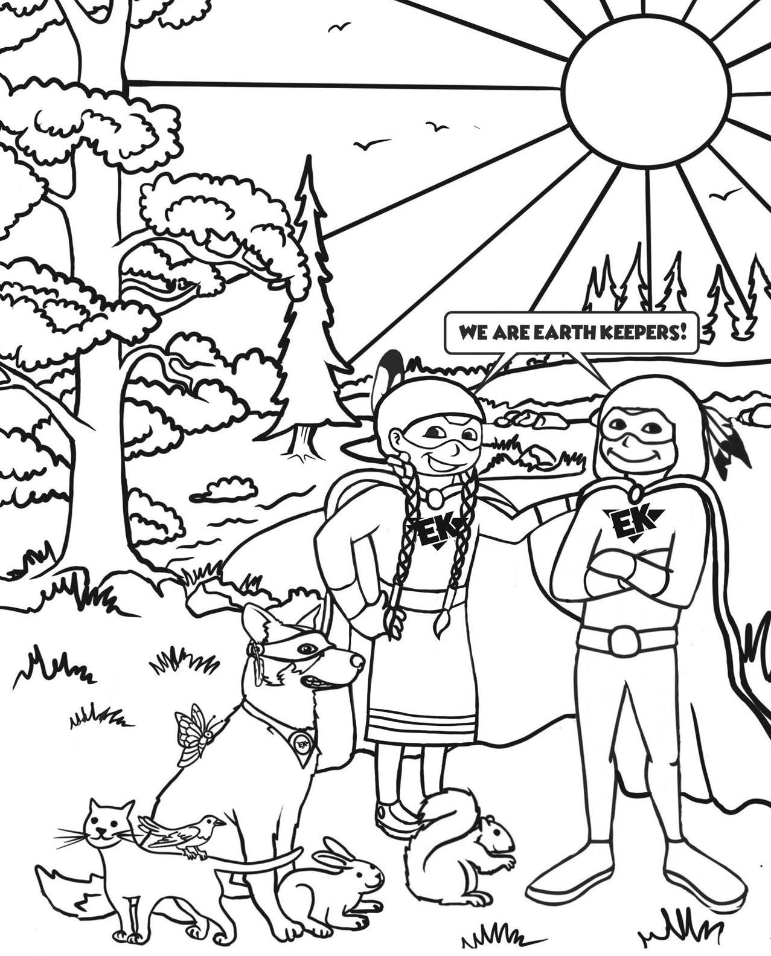

2

ARE YOU A LEVEL 2 EARTH KEEPER?
1 I care about the environment . . . . . . . . . . . . . . . . . . . . . . . . . . . . . . . . . . . . . . . . . . . . . . . . . . . . . □ yes □ no
- I can help the garbage truck driver by making sure my family puts only bagged
household waste out for him to pickup, and I always replace the lid after! . . . . . . . . . . . . □ yes □ no

Rethink
I can choose snacks that have natural packaging like an orange or banana . . . . . . . . . . . □ yes □ no

Refuse
I can say no to extra waste like plastic bags and use a cloth bag. . . . . . . . . . . . . . . . . . . . . □ yes □ no

Reduce
I only take the amount of food I know I will finish eating, I can always go
back for more if I am still hungry! . . . . . . . . . . . . . . . . . . . . . . . . . . . . . . . . . . . . . . . . . . . . . . . . . □ yes □ no

Reuse
Sometimes I wear hand-me-down clothes because they fitit me and are still nice!. . . . . . □ yes □ no

Recycle
I keep my water and juice boxes out of the waste bin so they can be recycled at
the bottle depot!. . . . . . . . . . . . . . . . . . . . . . . . . . . . . . . . . . . . . . . . . . . . . . . . . . . . . . . . . . . . . . . . . □ yes □ no

Animal Safety
I put garbage bags out for pickup in a place where birds and dogs cannot
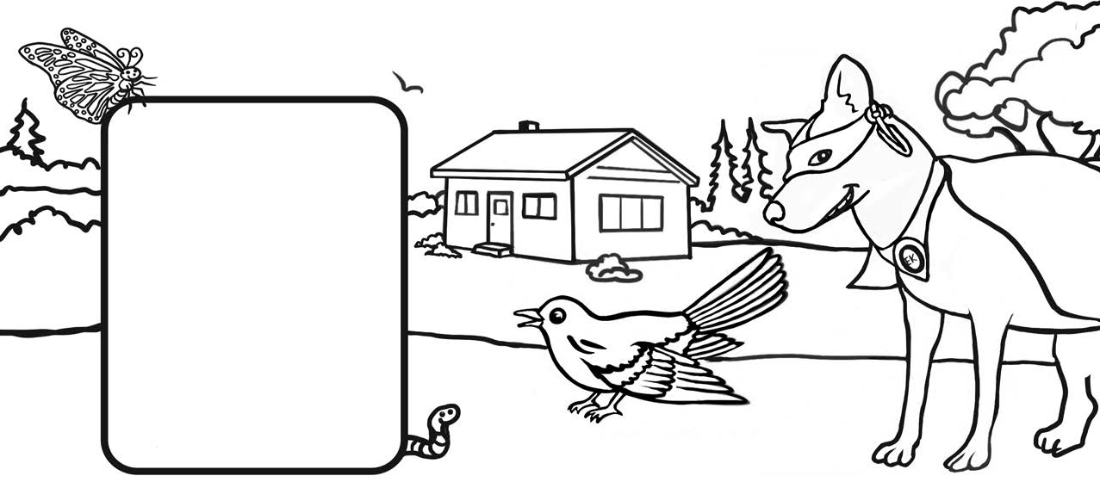rip them open.. . . . . . . . . . . . . . . . . . . . . . . . . . . . . . . . . . . . . . . . . . . . . . . . . . . . . . . . . . . . . . . . . . . □ yes □ no
No waste in the First place
Use it up!
Wear it out! Make it do or Do without!
3

 | TOOLS | MATERIALS
 | - Oven  - Knife  - Scissors | Cotton fabric cut into squares or rectangles. Beeswax beads, blocks or candle remnants

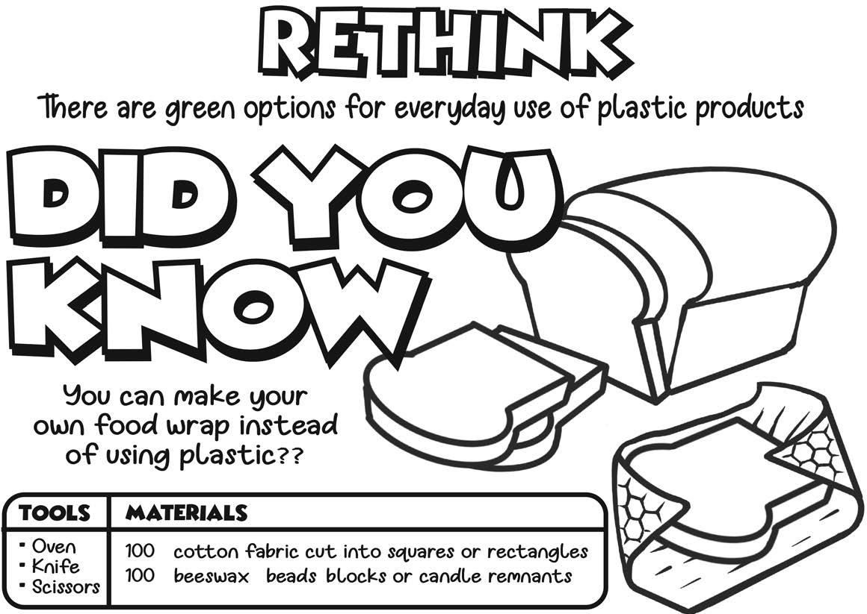INSTRUCTIONS

There are green alternatives for plastic products we use everyday
Preheat your oven to its lowest setting. 150º
F is ideal, but up to 170ºF

is fine too. Gather a few pieces of cotton fabric and put them on a baking sheet lined with tin foil.
- Shave and then chop a couple of ounces of beeswax.
- Sprinkle the fabric with a light layer of beeswax.
- Put them in the oven for 10 minutes or until wax is melted).
- Take them off the hot baking sheet IMMEDIATELY.
- Hold the wraps from the corners until they cool and solidify, this will just take a few seconds then lay them down flat.
NOTES

If your wraps get cracked or worn over time, just stick them back in the oven at the lowest temperature and remelt them.. They’ll come out like new!
Some people add powdered pine resin (dried tree sap) to their wraps. This adds stickiness that helps the wrap to cling to materials other than itself. It isn’t mandatory to use resin,
they work extremely well without it.
4

USE / BRING
YOUR OWN
SAY NO THANK YOU TO A
PLASTIC BAG

What is better for the environment? A toy wrapped in a lot of packaging or a toy with little or no packaging? Circle and color the best choice!
Colour the picture of the type of bag your family uses at the store!

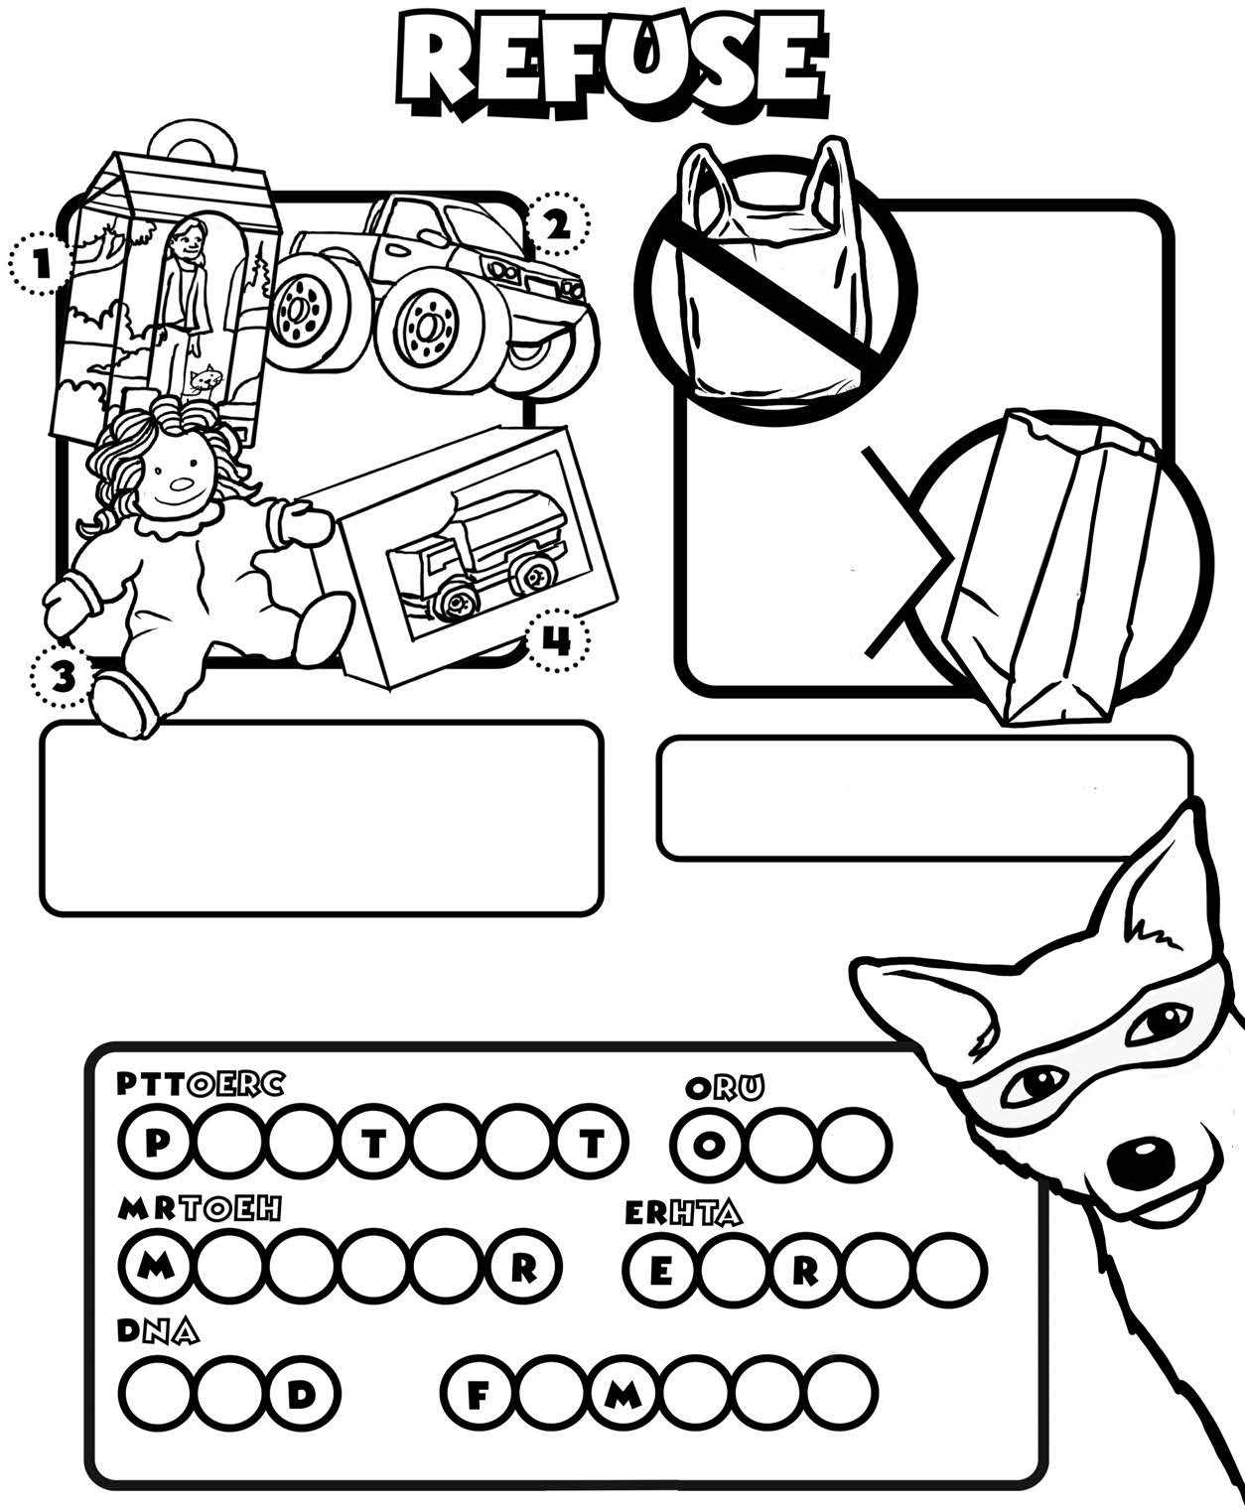

UNSCRAMBLE THE LETTERS TO REVEAL THE SPECIAL PHRASE

LY F A I M

Answer Key on Page 20

5

gtyrofoam breaks down into very small pieces and animals that live in the water can mistake it for food.

gtyrofoam can take up to 500 years to break down but will never fully decompose.

0

ESTIMATED DECOMPOSITlo.l RATES
paper Leaves orange peeLs MiL!( carton pLastic bag

Reusable cutlery
•A •

B C D E

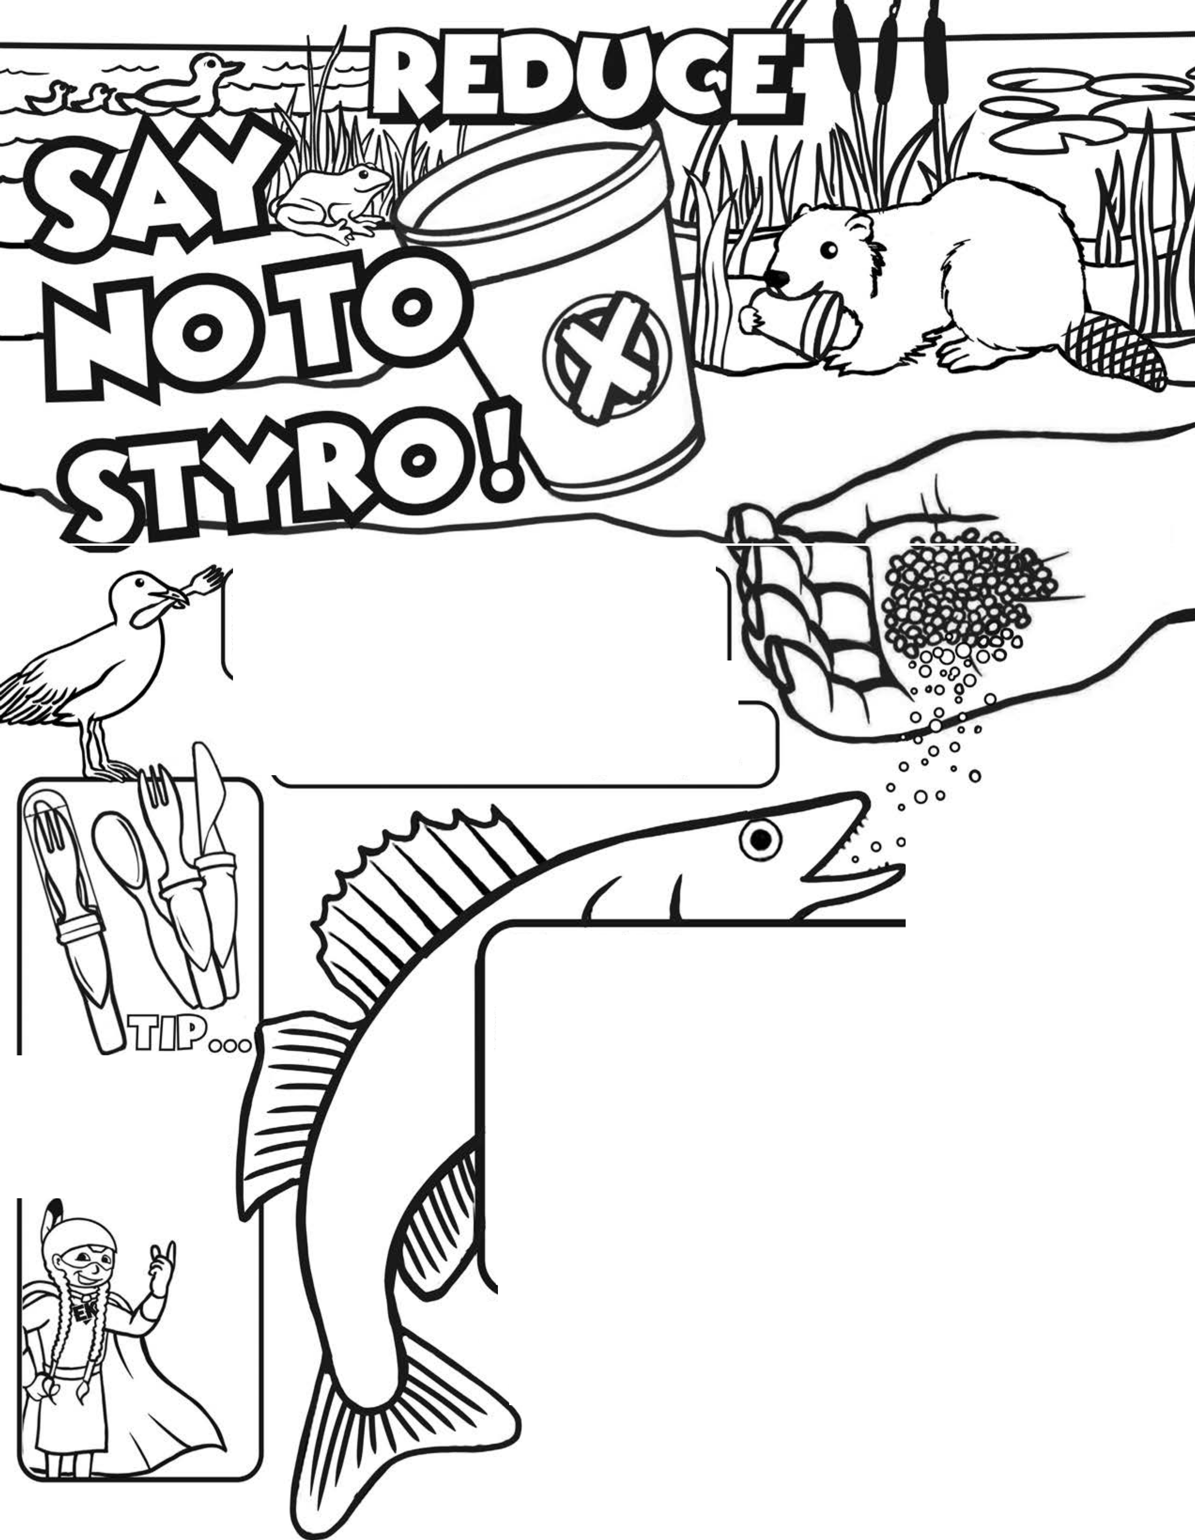to curb the use of single use plastics are a great idea!
aLuMiroM can plastic 6 pac!( pLastic bottle gLass bottle st rof'oaM
D tJ
Q
F G H I J
MATCH TH£ L£TT£Rg ABOVE TO TH£ 0£COMPQglT(or,JRAT£g BELOW...
l._ 5 years 2. _ Never? 3 ._ 3 to 6 months 4 ._ 500 Years-Forever?
5 . _ 10 to 20 years 6. _ 20 0 to 400 years 7._ 4 0 0 to 500 years
© 8._ I to 3 months 9._ 2 to 4 weeks
6
I0. _ 4 0 0 -500 years

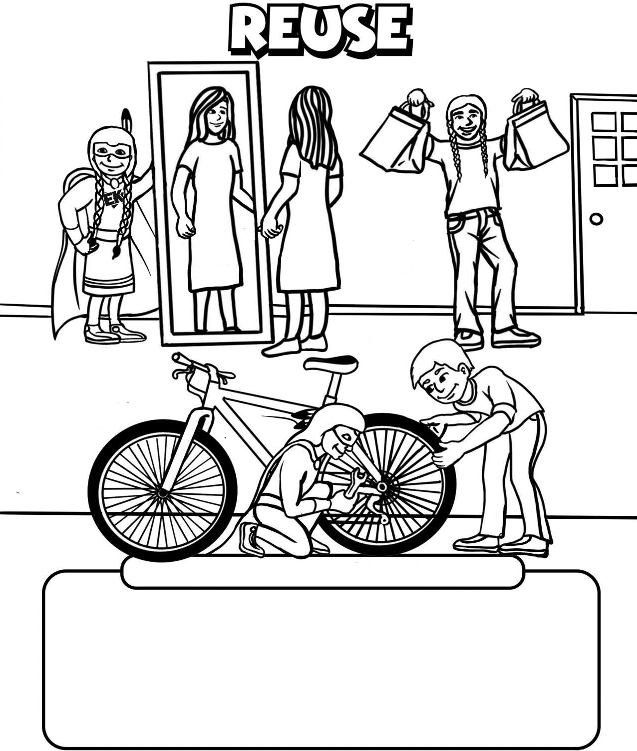

REUSE
can be wearing hand-me-down clothing or...

... REPAIRING
a broken bicycle

DRAW AN EXAMPLE OF SOMETHING BEING REUSED!

7

Recovery technology uses waste that cannot be recycled to create a green energy source.

Recovery technology also helps save space in our landfills and the energy generated can power your home!

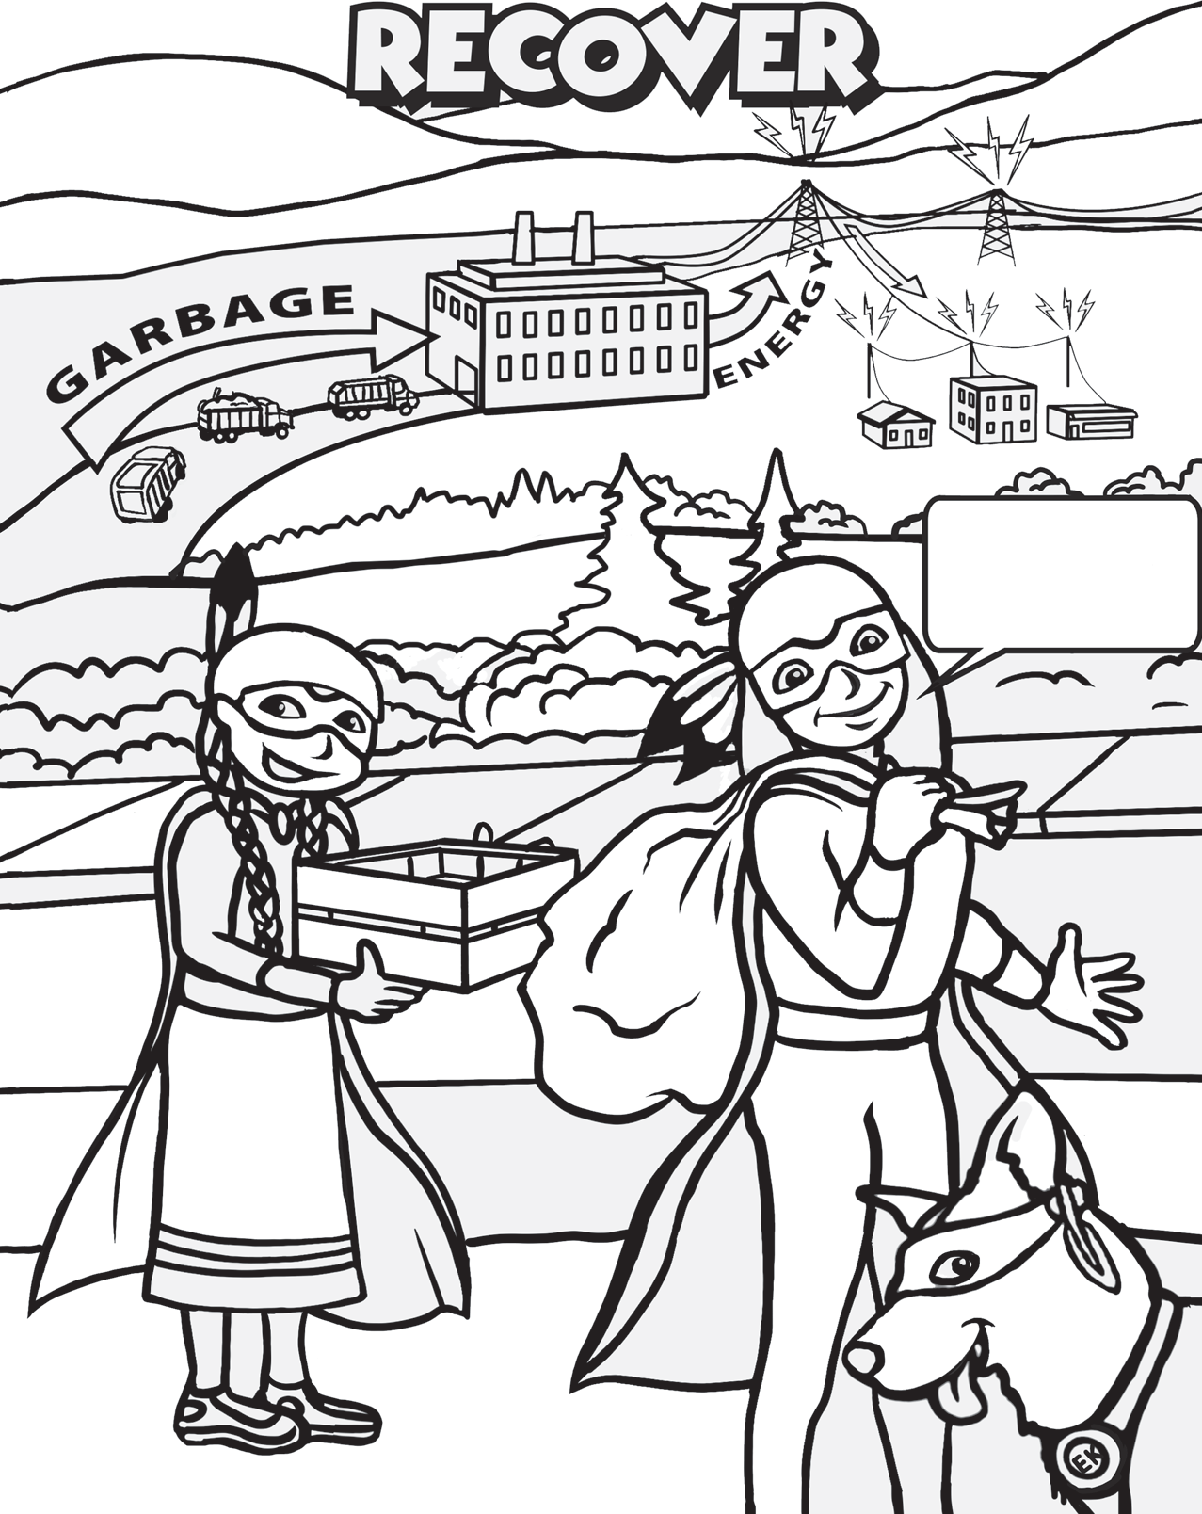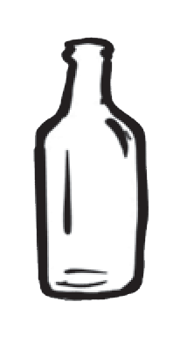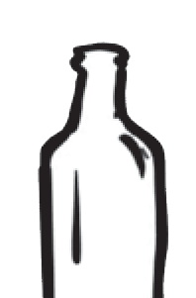

8

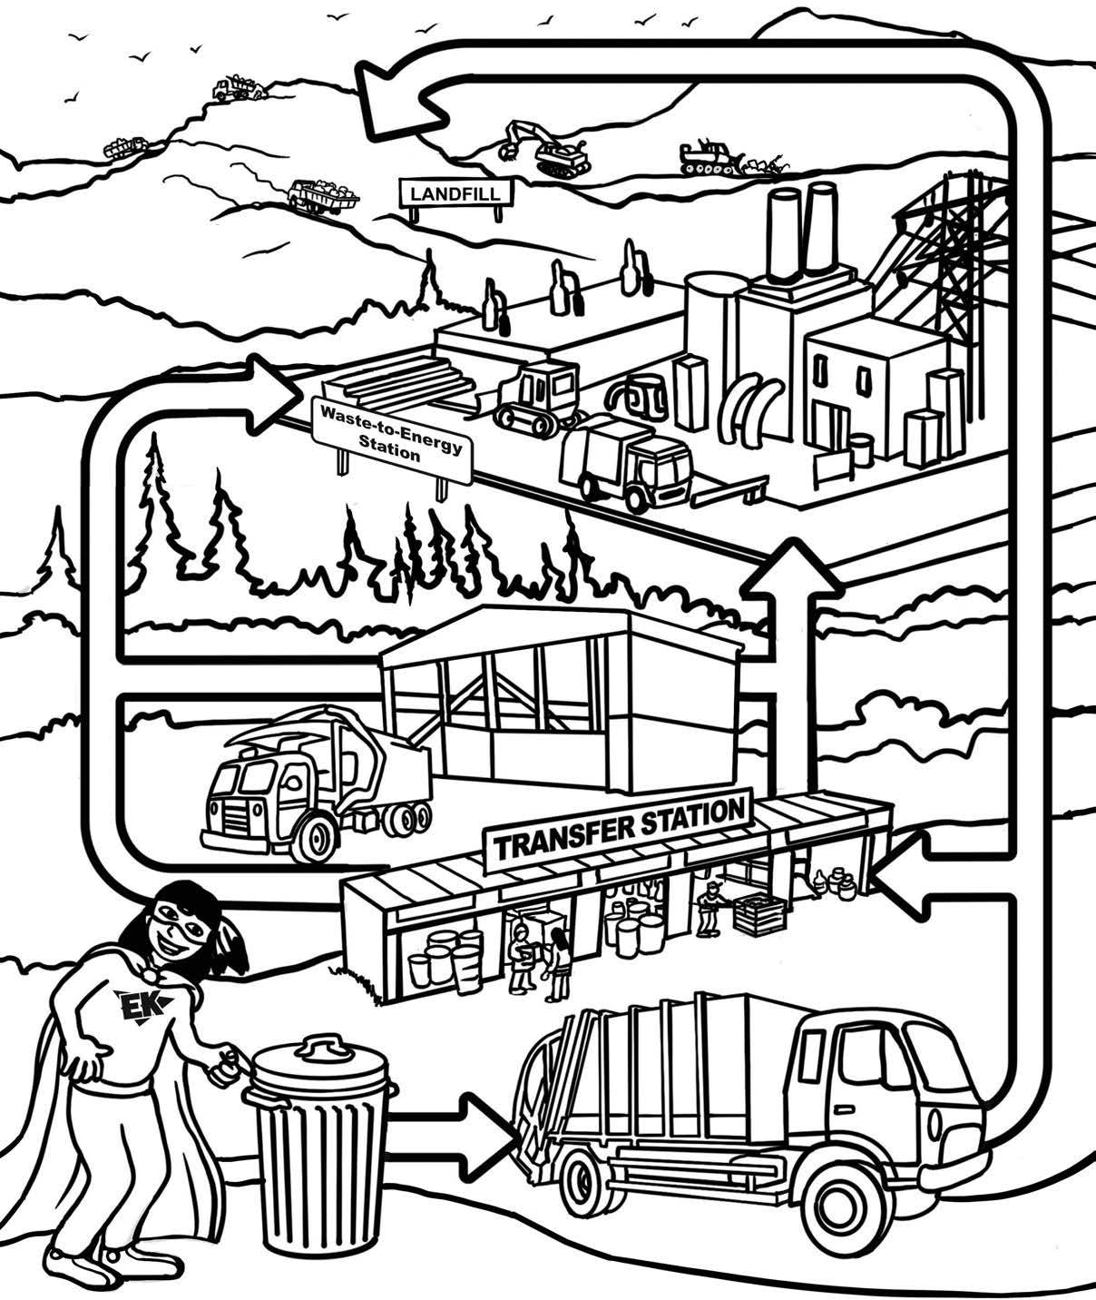waste diversion

9

COLOR THE PATHS TO HELP ALL OF THE BOTTLE TYPES MAKE IT TO THE COUNTER FOR A REFUND!

.10 - .25¢
.10¢
.10 - .25¢
.10 - .11¢ .10 - .25¢

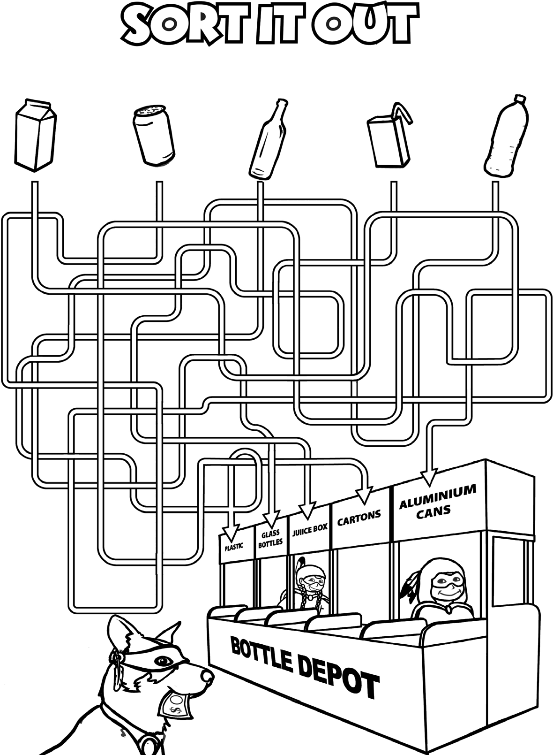

WOOF WOOF!!
It does make sense to make
cents! 10

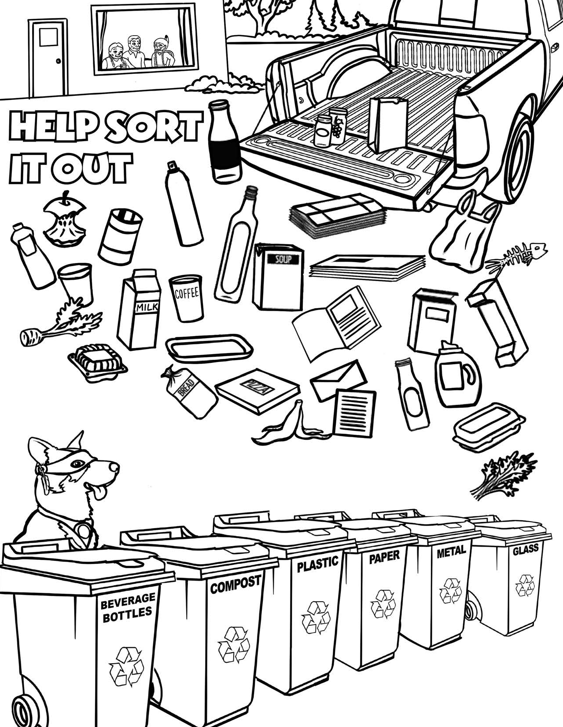

Pick a colour for each bin and colour it in. Then help sort each item by colouring it the same colour as the bin it belongs in!

11

There’s a lid on the can because some of the things in there can make me very sick!

Keep us safe! Keep garbage away from our curious jaws and paws!!

ALL OF THESE HUMAN FOODS CAN BE VERY POISONOUS TO OUR PETS.
Match the food item with its name on the right by writing its number in the box.

Grapes and Rasins Coffee beans, Coffee Alcohol
Chocolate
Garlic and Onions Nuts
Sugar

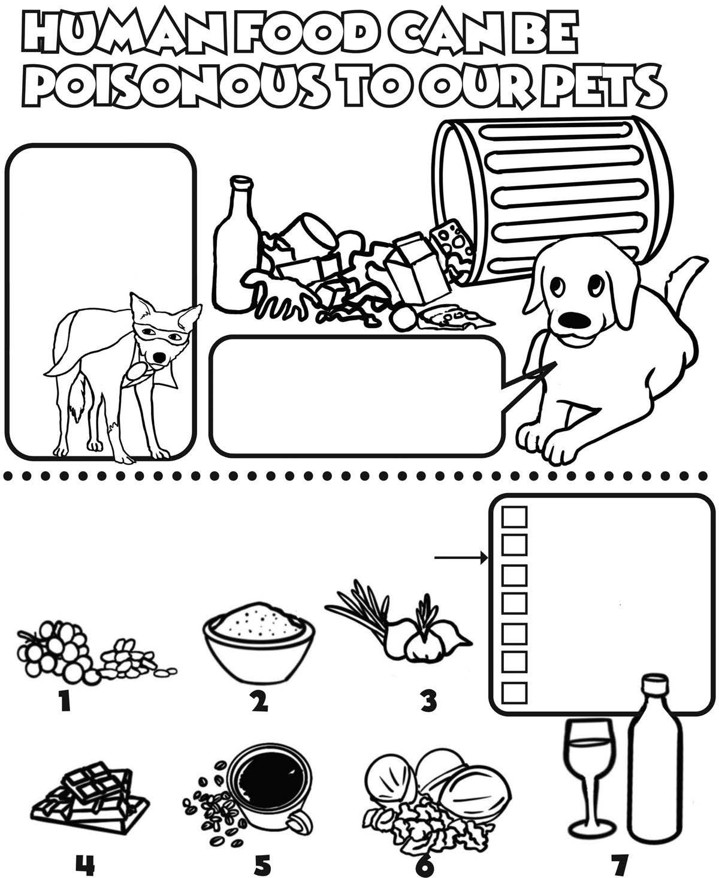

12

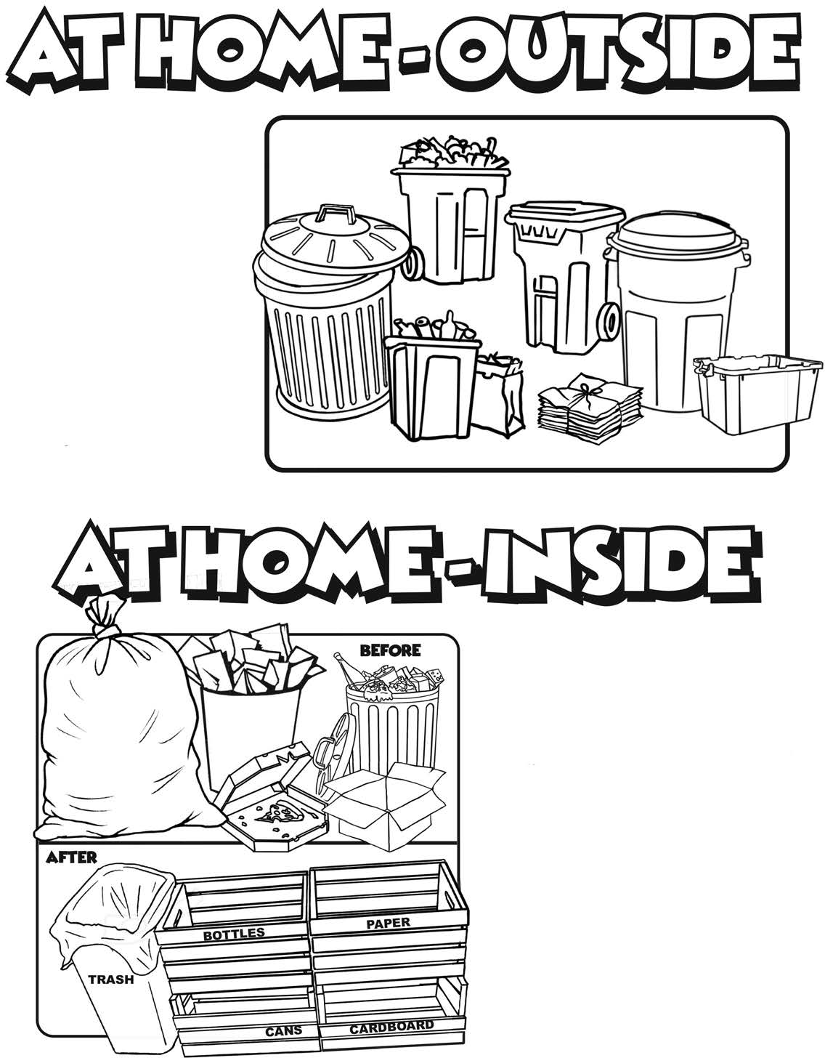

Circle the type of outside bin you have for garbage and recycling!

What type of bin do you have
for recycling and garbage inside??

FUN FACT!
The average person has the opportunity to
recycle more than 25,000 cans in a lifetime.
13



Help our garbage collection driver get his truck back on the road by connecting the dots and coloring it in, quick before the garbage bags pile up!

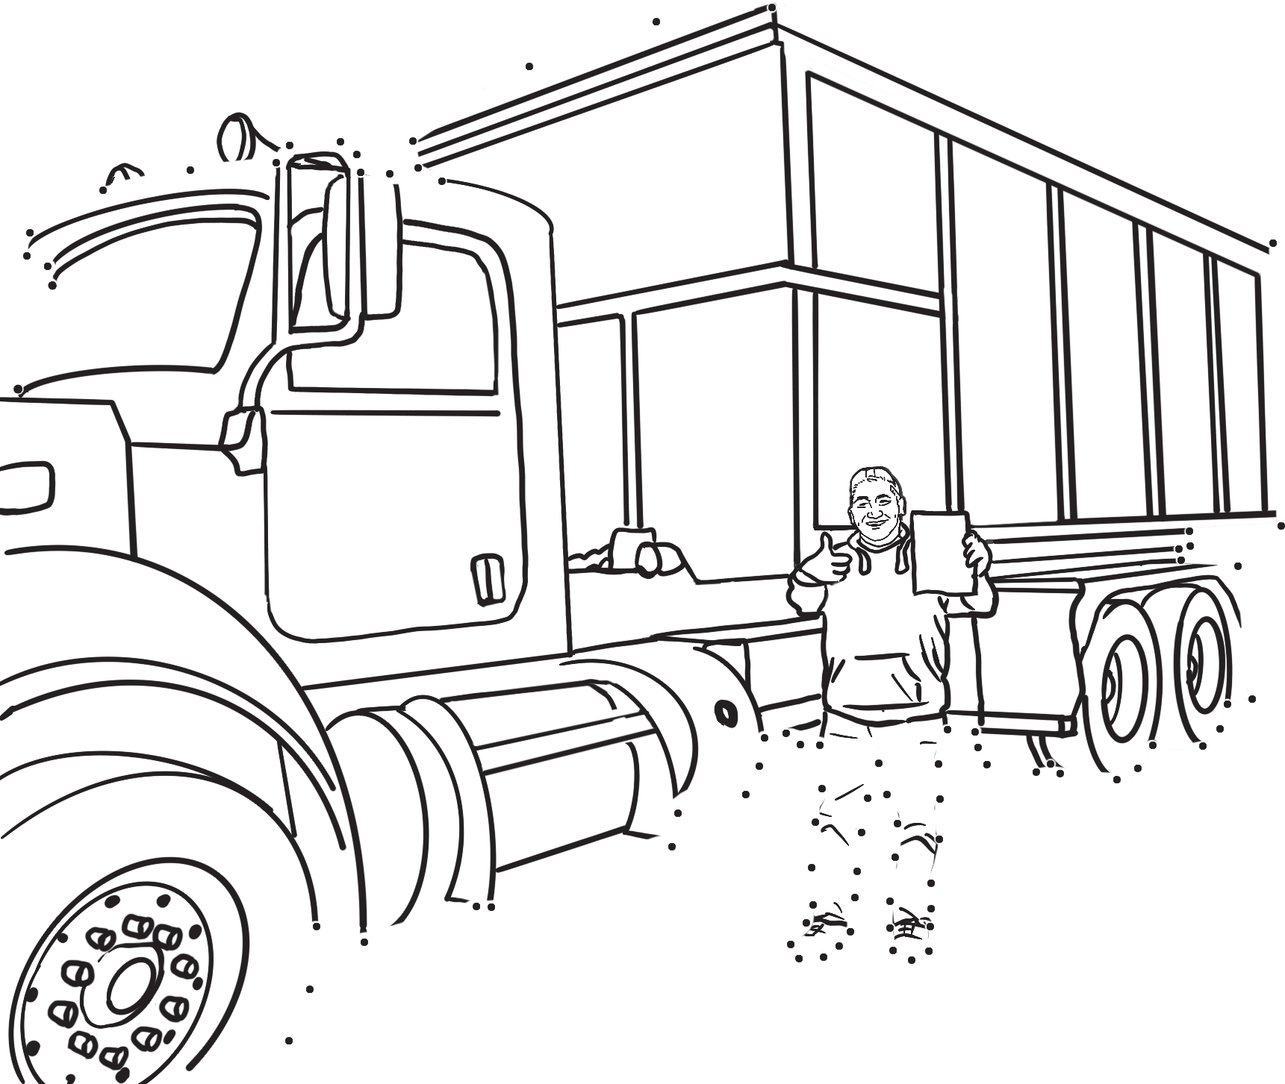18 19

9 10 11 16
7 8 15
12
13
6 14
5 20
4 3
2

1

24 23 21
22
25 26

72
73 71 70 55

39
4038 35
27
28
29
31 30

74
69
75
76
68
77
56 54
57 53
41 37 36 34 32
42
33
43

81 79 78
80
82
83
84
67 52
58 44
66 59 51 45
65
60
46
50
64 62 61 49 47
63
48

14

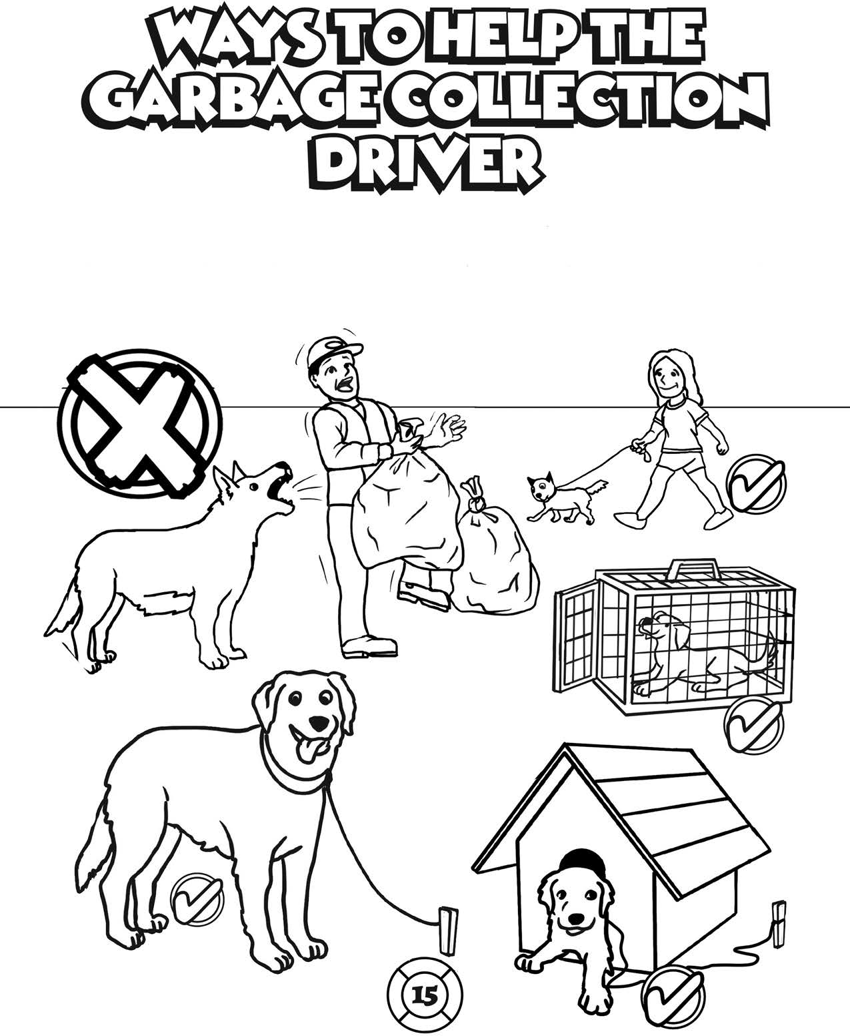

Dogs like to protect their home and don’t know the garbage collection driver from an uninvited guest. Put your dog on a leash, in a kennel or inside the house for garbage day pickup time

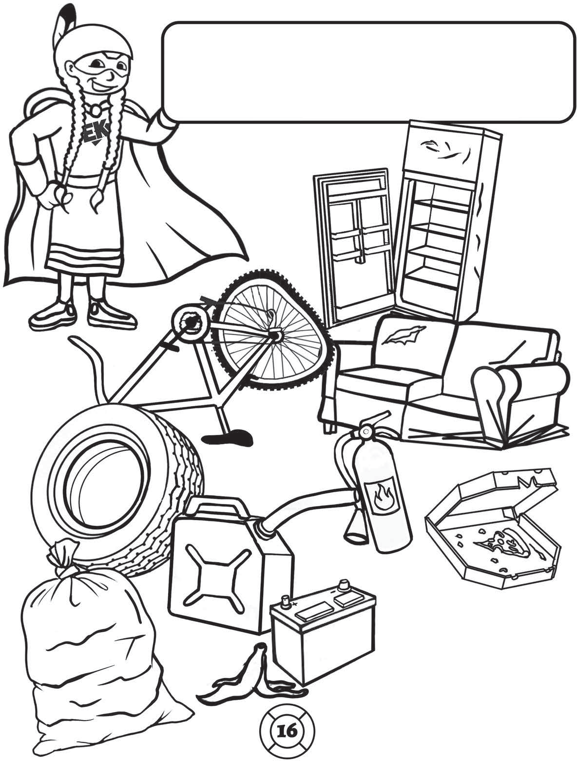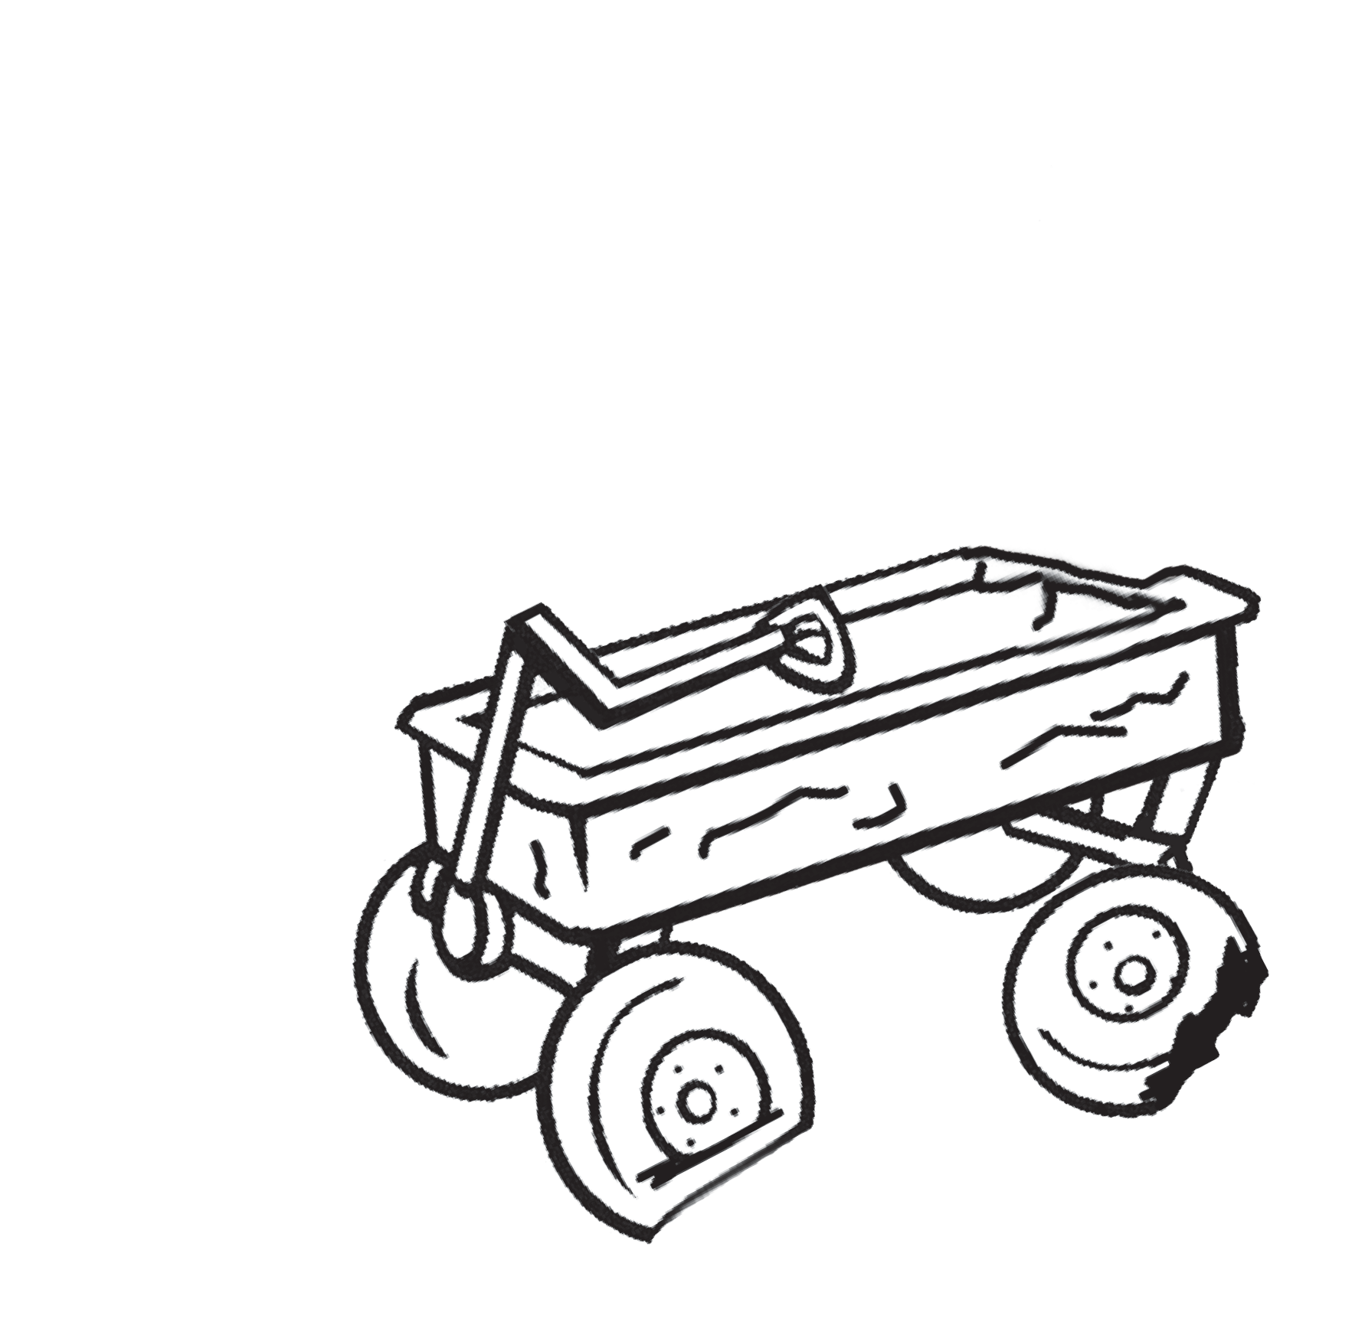The Earth Keepers see some items that can be repaired, reused, repurposed or recycled instead of going into the landfill. Colour the ones you can find!

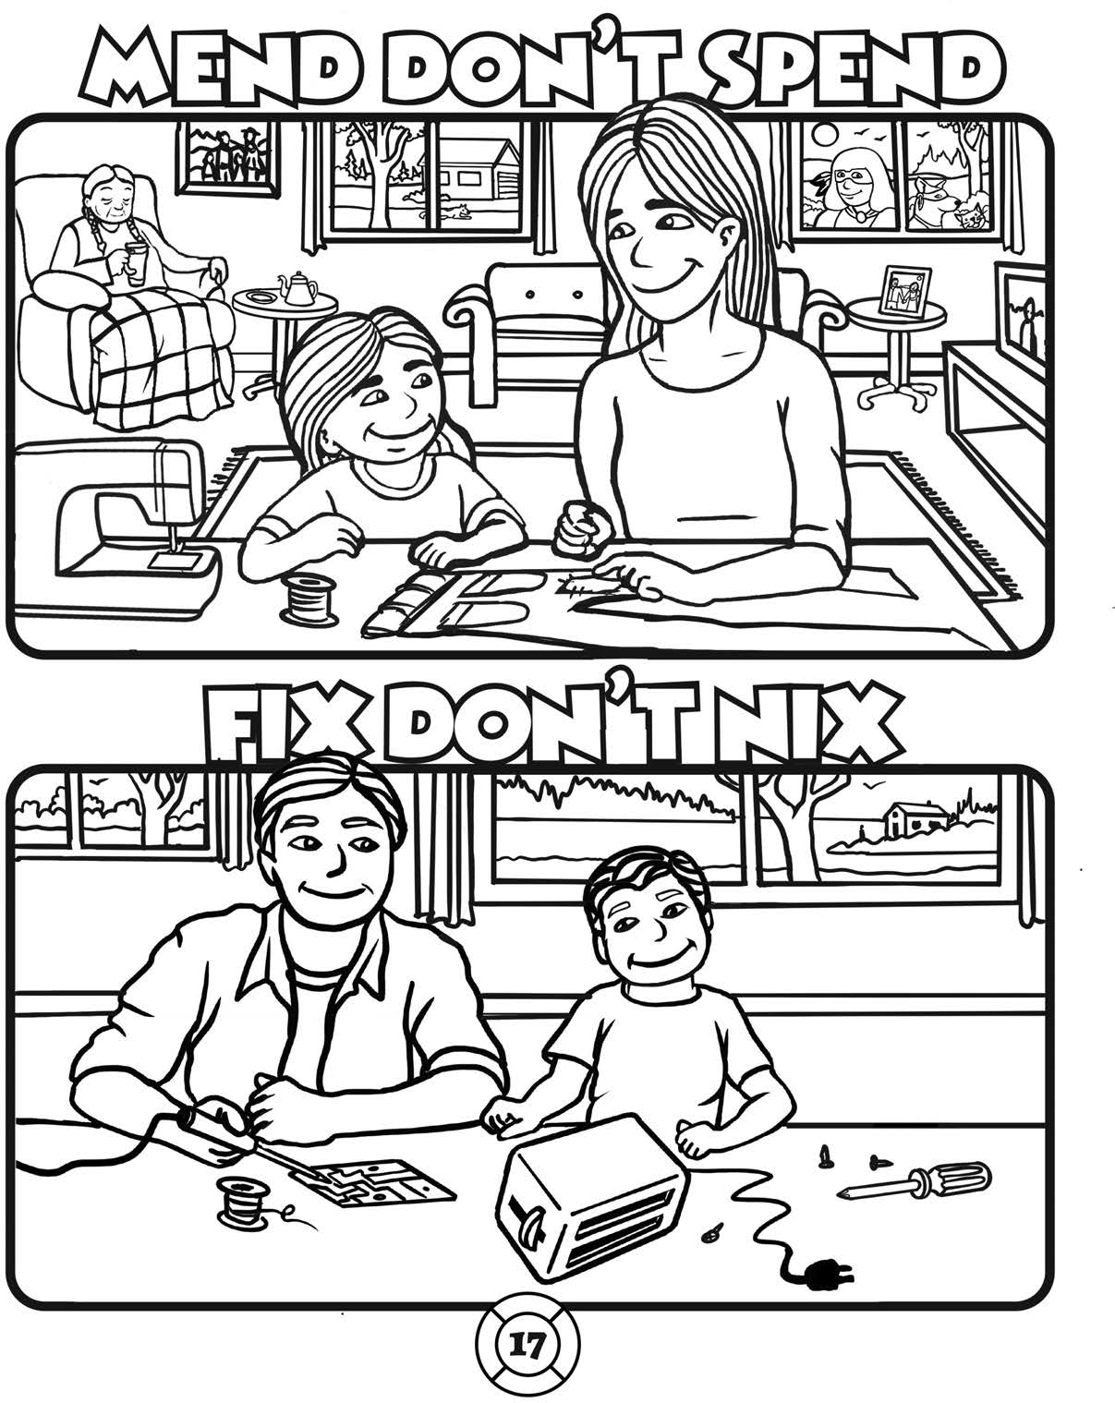
Reduce waste by fixing instead of buying something new

PREVENT - STOP - NO LITTERING

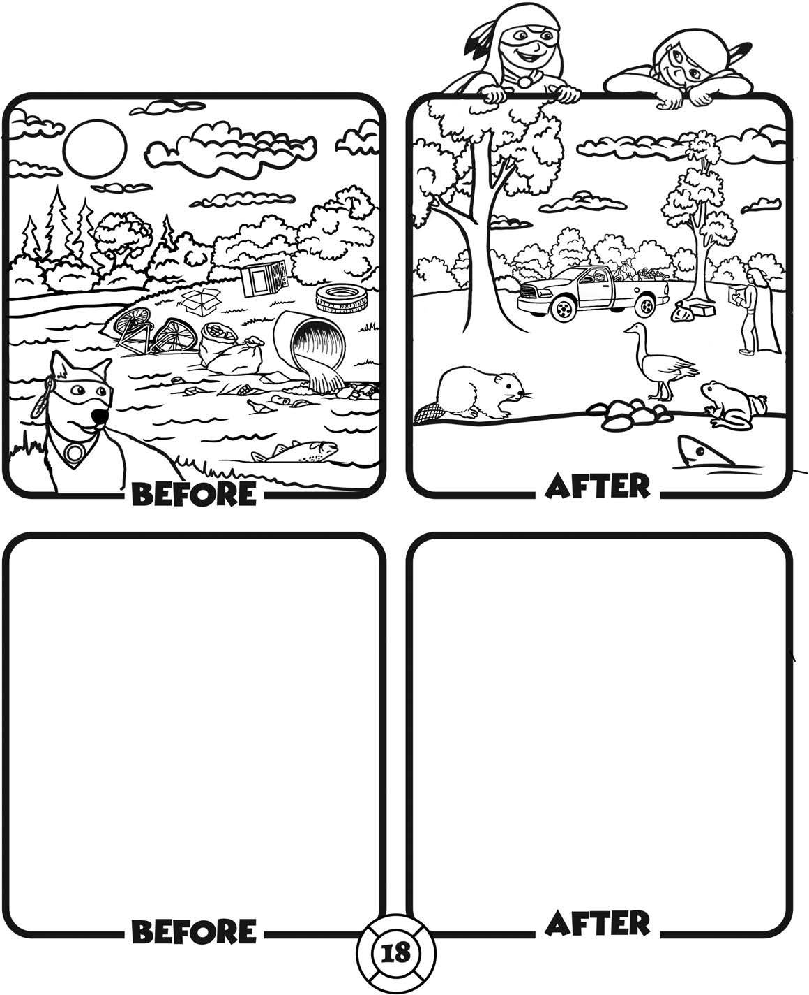
What do you think Mother Earth would say about littering?
Draw and colour your idea!

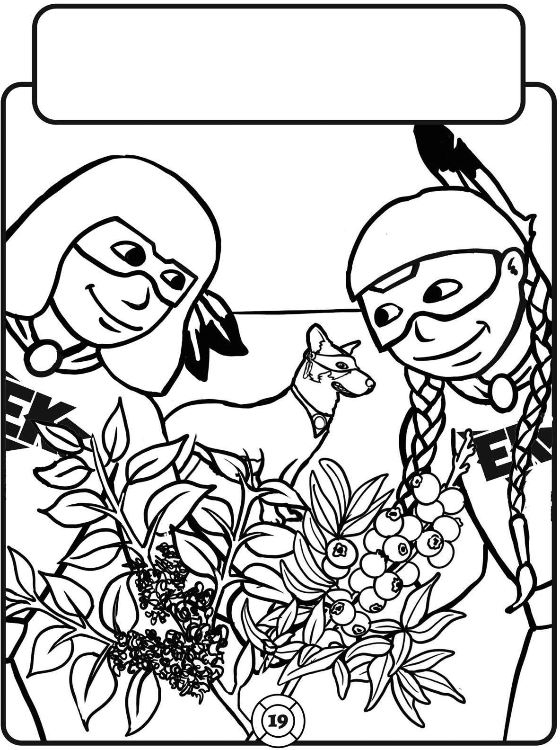
Protect our medicinal plants and berry patches by
NOT LITTERING!

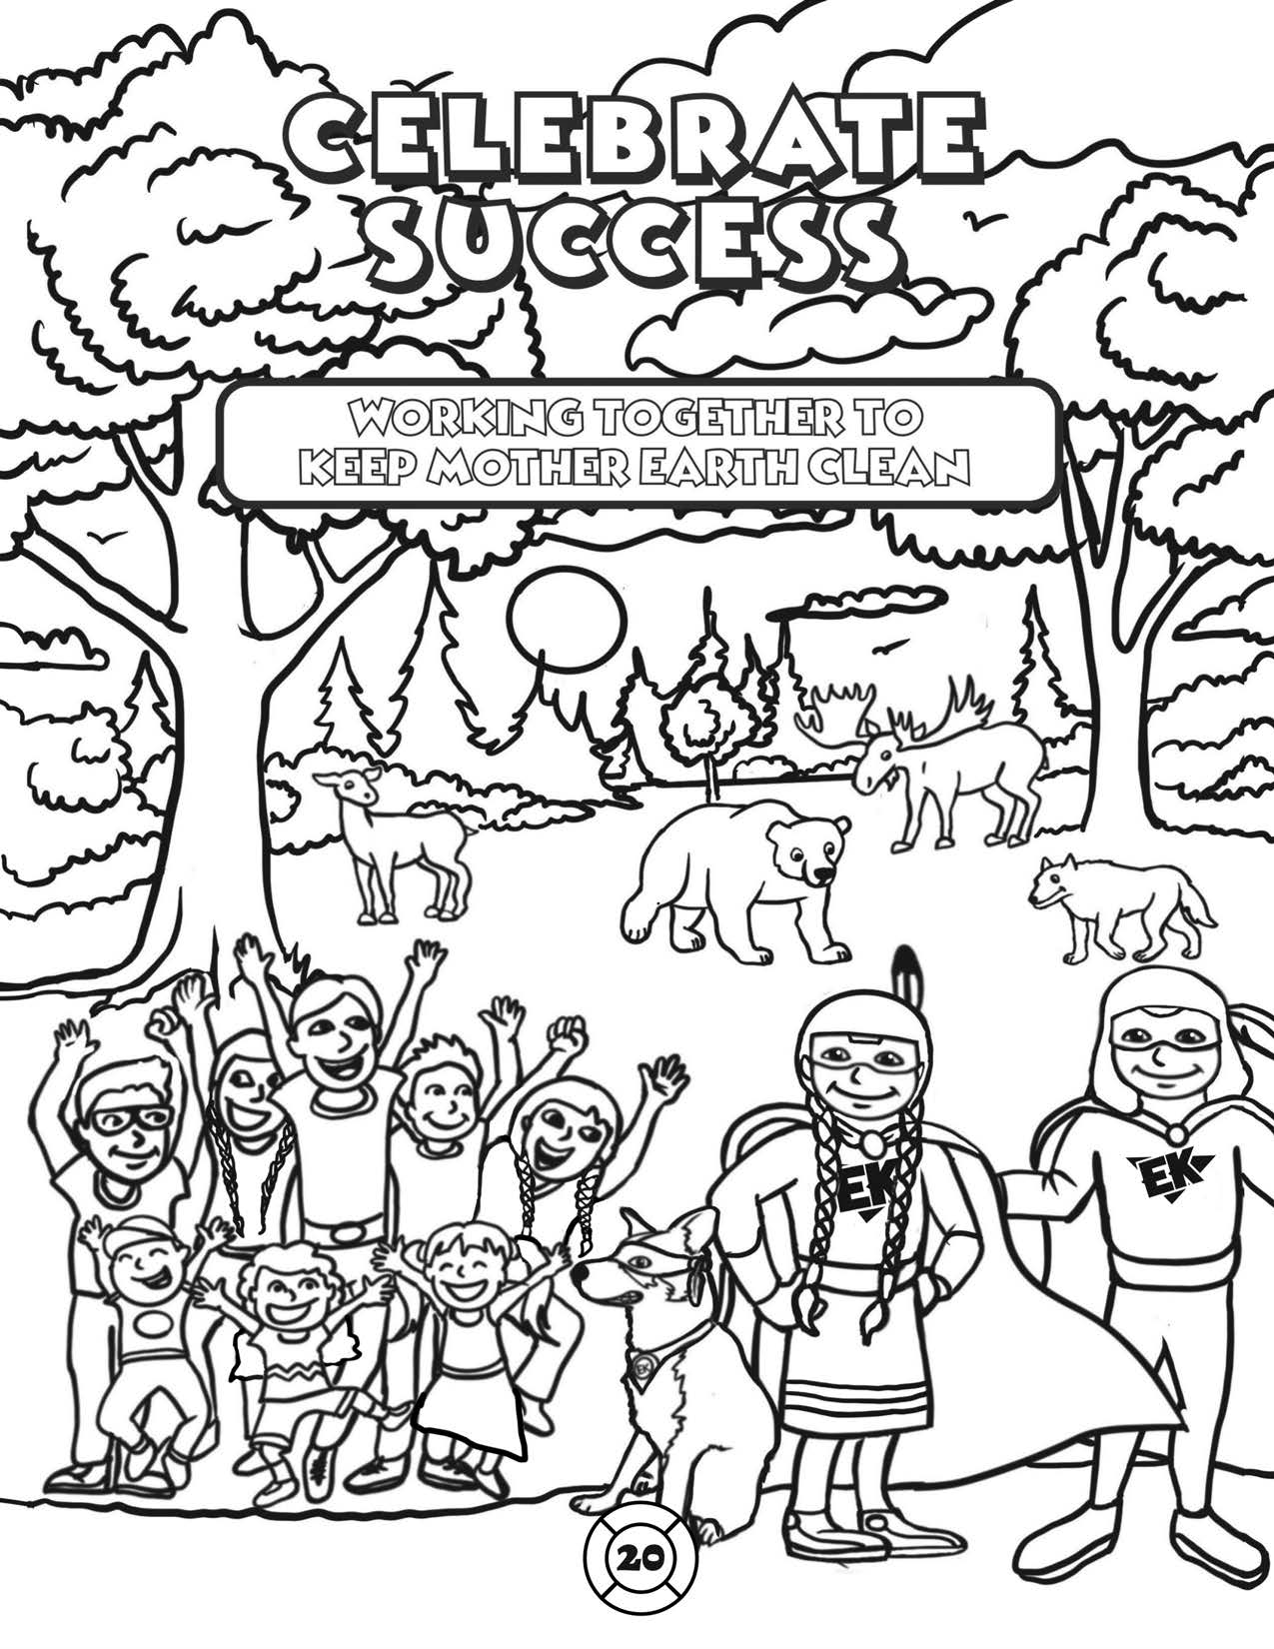

USE A MIRROR TO SEE THE ANSWERS FROM PAGE 6!

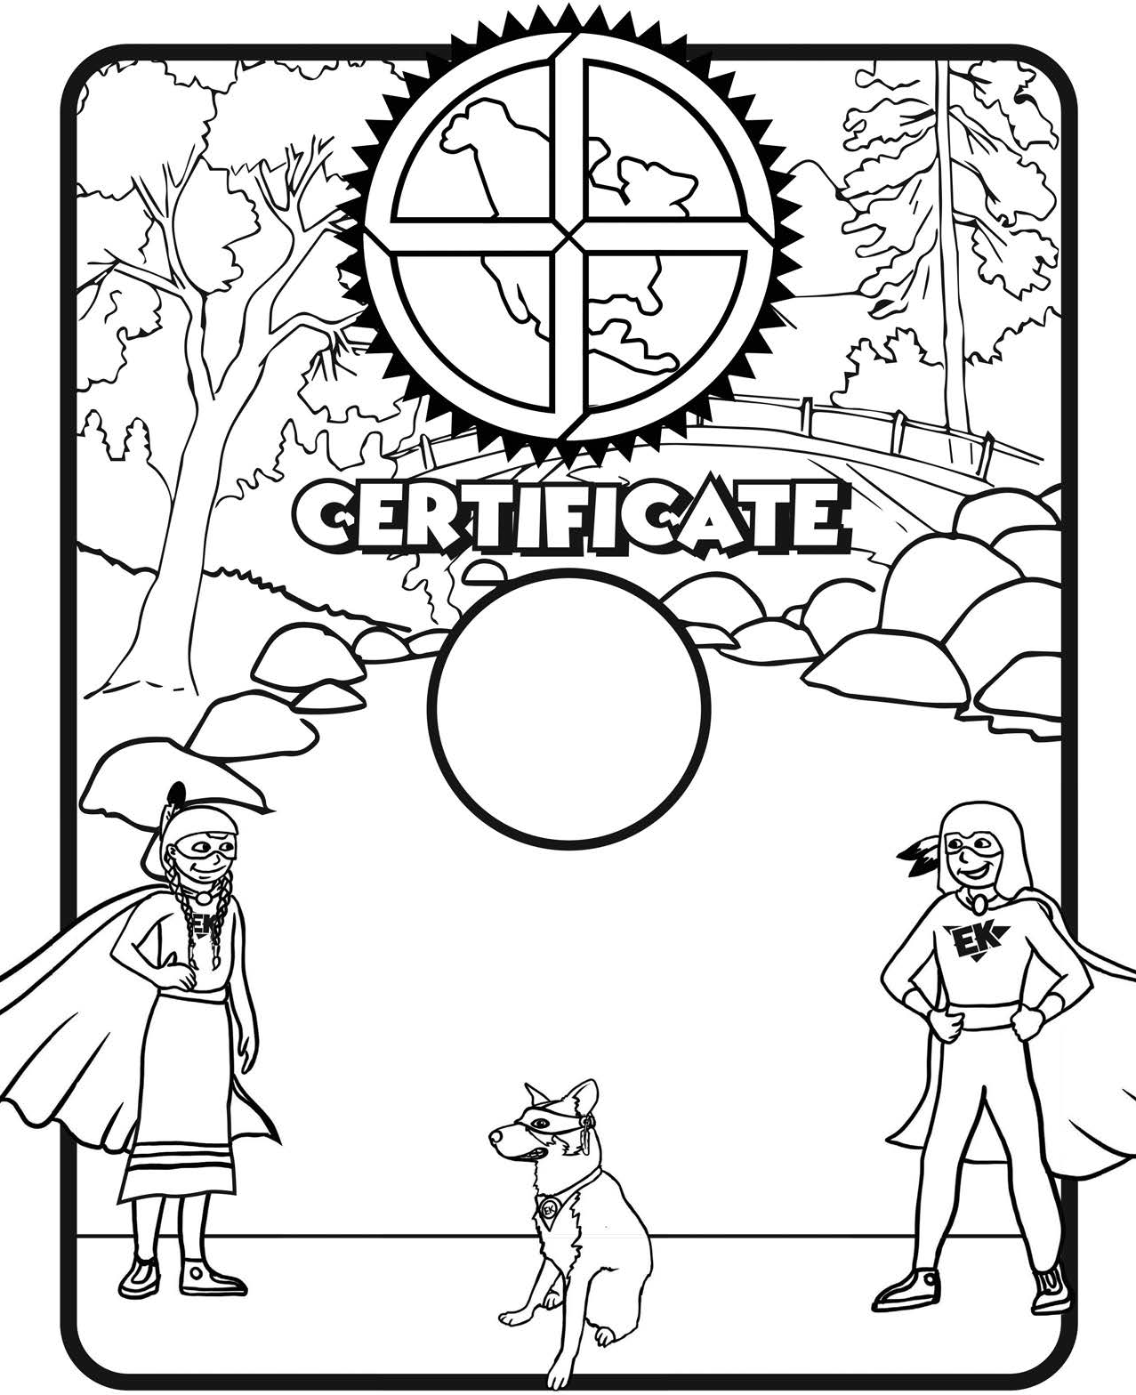

2
This is to certify that

has trained to be a Level 2 Earth Keeper

