NAME: _______________________________ |  | RANK: ________________________________
JACKET SERIAL NUMBER: _________________ |  | PANT SERIAL NUMBER: __________________
DATE OF MANUFACTURE: _______________  ^{MONTH / YEAR} |  | DATE OF MANUFACTURE: _______________  ^{MONTH / YEAR}
SIZE: ______________________________  ^{CHEST / LENGTH / SLEEVE} |  | SIZE: ________________________________  ^{WAIST / INSEAM}
COAT FRONT – Circle Dirty/Damaged Areas  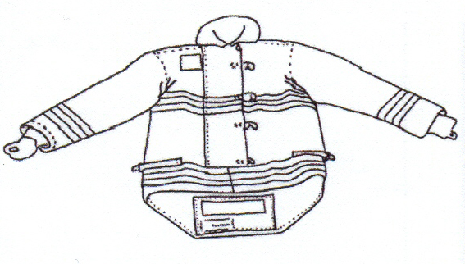 |  | PANT FRONT – Circle Dirty/Damaged Areas  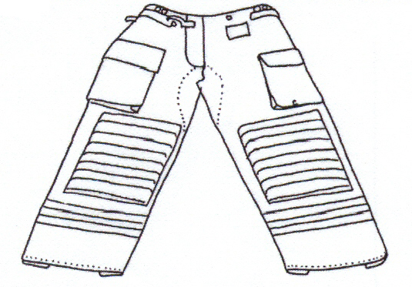
COAT REAR – Circle Dirty/Damaged Areas  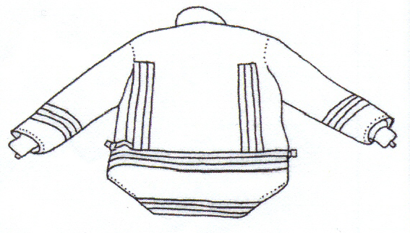 |  | PANT FRONT – Circle Dirty/Damaged Areas  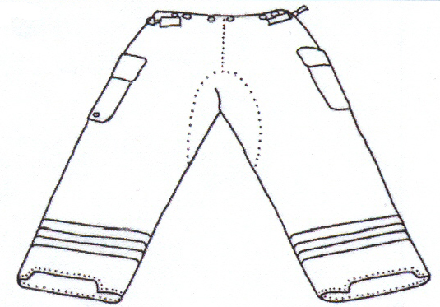
HELMET  Clean: Yes ☐ No ☐  Damage: | GLOVES  Size: _______  Clean: Yes ☐ No ☐  Damage: |  | BALACLAVA  Clean: Yes ☐ No ☐  Damage:
BOOTS
Size: ______
Clean: Yes ☐ No ☐

