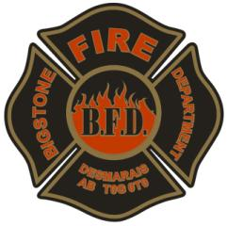
BFD Equipment Inventory
Personnel Equipment

Name: _______________________________________________ Date: ___________________

Locker Number: ________________

(Poor, Fair, Good)
 | Equipment | Condition | Year
 | Fireman Helmet
 | Fire Coat
 | Fire Pants
 | Gloves
 | Balaclava/fire hood
 | Fire Boots
 | Pager
 | Radio
 | Fire Gloves
 | Coveralls
 | MVC Gloves
 | Safety Glasses
 | N95 Mask
 | Hazmat Suit
 | Wild Land Boots
 | Station Wear

Supervisor sign off: ______________________________________ Date: _____________

