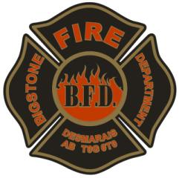
BFD Equipment Inventory

Location: ______________________________________ Date: ___________________

Equipment | Number of units |  | Equipment | Number of units
38 mm hose
65 mm hose
Forestry hose
38 mm nozzle
65 mm nozzle
Hooligan
Pike pole 20 feet
Pike pole 8 feet
Pulaski Axe
Spann Wrench
Shovels
Gated Valve
Gated Y
Hydrant Wrench
SCBA’s Vikings
Fireman Helmets
Fire Coat
Fire Pants
Gloves
Balaclava/fire hood
Fire Boots
Way jacks/piss pack
First Aid kits
Burn Kits
Blankets
Radios
Jaws of life
Trash pump
Generator
AFD Pulse

We got three Apparatus
Fire Truck | PW1-16 | White | 2000 | GMC | Top Kick | 1GDP7H1C11J502735 | VZM-487
Fire Truck | PW1-29 | Red | 2010 | International 74005BA 4x2 | Workstar | 1HTWCAAR3BJ313483 | BCV3863
Fire Truck | PW1-30 | Red | 2011 | International 74005BA 4x2 | Durastar | 1HTMKAAR8CH460806 | BDZ 4832

